REPUBLIC OF RWANDA.

GATSIBO DISTICT

SCHOOL………………………………………………………….

NAMES…………………………………………………….

CLASS P5 ……………………………………………………..

END OF SECOND TERM.

SOCIAL AND RELIGIOUS STUDIES EXAMINATION

ACADEMIC YEAR 2022-2023

TIME: TWO HOURS

|  |  |
| --- | --- |
| MARKS | SCORED |
| 100 |  |
|  | |

INSTRUCTIONS:

* Write your name correctly.
* All questions are compulsory.
* Read each question carefully before answering it
* Write your answers in the space provided.

SECTION A 60 MARKS

1(a)What is the different between a map and picture?

………………………………………………………………………………………………………………………………………………………………………………………………………………………………………………..2marks

b. State any three elements of a good map that you know

i………………………………………………….ii………………………………………………………………………iii……………………………..

………….

2. ……………………………….is a place where something is found.

3.Write any three examples of cardinal points of a compass

i……………………………………………………………………

ii………………………………………………………………….

iii………………………………………………………………..3marks

4.A province in Kinyarwanda is called……………………1mark

5. Name any three provinces that neighboring Kigali city.

i………………………………………………………..ii………………………………………………iii………………………………………./3marks

6. In which province of Rwanda do we find lake kivu?

………………………………………………………………….

7.Name the smallest and the biggest province of Rwanda.

a) smallest………………………………………..

b) biggest…………………………………………../2marks

8. Match the following province with their district./5marks

a) East karongi

b) south Kigali

c) West Rwamagana

d) North Nyanza

e) central musanze.

9. How many provinces are there in Rwanda?

………………………………………………………/1mark

10. In which direction is does the:/2marks

a) sun rise…………………………………………………

b) sun set…………………………………………………..

11. What do you understand by term complementarity?

………………………………………………………………………………………………………………………………………………………………..1mark

12.a. Who is a child?

……………………………………………………………………….1mark

b. List any three form of child abuse that abuse that you know

i…………………………………………ii…………………………………………………iii………………………………………………………………3marks

13. Define the following terms.

i. Harmony…………………………………………………………………………

ii. Disharmony…………………………………………………………………………………………………………………………………….

14. Which of these is not a way of maintaining peace.

………………………………………………………………………1mark

1. Forgive one another.
2. Respecting one another.
3. Fighting one another.

15.Mention any two national or international organization that advocate for human rights.

i………………………………………………..ii……………………………………………………2marks

16.a What is sanitation?

…………………………………………………………………………….1mark

b. Give any two activities involve in sanitation.

i…………………………………………ii………………………………………

17.Write any three things which are used to keep our surroundings clean

i……………………………………………ii………………………………………..iii………………………………………………….

18. Give any two things we can do, in order to keep our bodies clean

i…………………………………………………ii……………………………………………

19. Write the form of the following;

i AIDS………………………………………………………………………….

ii. HIV…………………………………………………………………………

iii. STLS…………………………………………………………………….

20.Name any two sexual transmitted diseases that you know.

i…………………………………………….ii……………………………………………..

21. Suggest two ways of preventing the spread of HIV in our province.

i………………………………………………….ii………………………………………………………………………..

22. Write any two examples of acceptable behaviors.

i………………………………………ii…………………………………………….

23…………………………………………..is a country free from colonial rule or any external influence.1mark

24. Give any three symbols of a national.

i……………………………….ii………………………………………….iii……………………………………………………………………

25. Name the person who designed the Rwanda national flag

…………………………………………………………………….1mark

26.Name the colours marked A, B and C /3marks

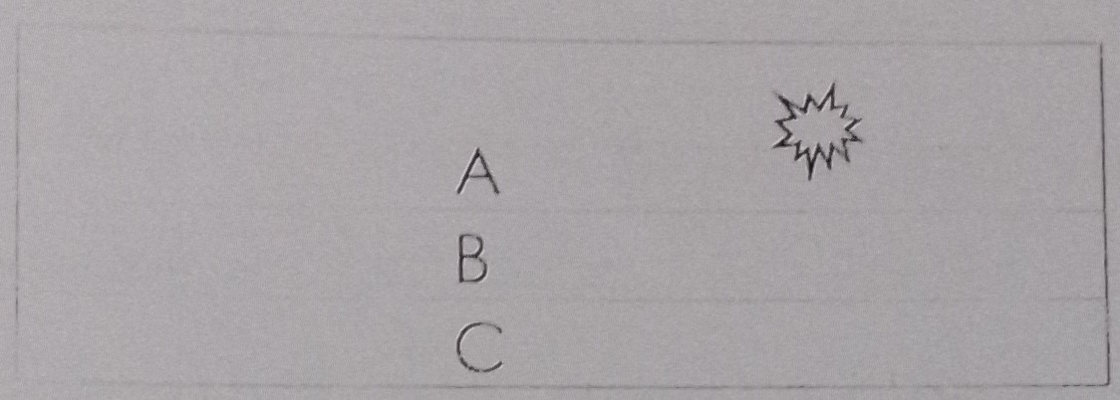

27. Identify any three places where the national flag is raised.

i………………………………………ii………………………………………..iii………………………………………………………………3marks

28. State any three features found on the Rwanda national coat of arm.

i………………………………………………….ii………………………………………………………………………….iii……………………………………………/3marks

29.Who is a leader?

………………………………………………………………………………………/1mark

30.Explain any three qualities of a good leader.

i…………………………………………….ii……………………………………………………..iii…………………………………………………/3marks

31.What is Economy?

………………………………………………………………………………………

32. State any two economic activities that people do to get money.

i………………………………………………ii………………………………………….2marks

33.What is budget?

………………………………………………………………………………………/1mark

34.Mention any two parts of budget that you know.

i………………………………….ii………………………………………………………………./2marks

35. What are basic needs?

………………………………………………………………………………….1mark

36. List any two examples of family’s basic needs/3marks

i…………………………………………….ii………………………………………………….iii………………………………………………………

37. Why people should save money?

……………………………………………………………………………………1mark

38……………………………………….is an institution that keeps people’s money safe and provides other financial sevices.1mark

39. Write any two banks that found in Rwanda

i………………………………………………ii……………………………………2marks

40. Give two importance of banks in Rwanda./2marks

i………………………………………………………………..ii………………………………………………………………………

41.a. What is weather?

……………………………………………………………………………………………………

b. State any two elements of weather that you know/2marks

i…………………………………………………..ii……………………………………………….

42. What is meteorologist?

………………………………………………………………………………………………………………………………………………………………………1mark

43. Give the meaning of the following terms.

i. Afforestation

…………………………………………………………………………………………….

ii. Deforestation

……………………………………………………………………………………………………..

44. Give any three examples of lakes found in Rwanda/3marks

i………………………………………………………

ii………………………………………………………

iii………………………………………………………..

45. Match the items in A with those in B those in 5marks

A B

Wind vane to measure the temperature.

Barometer to measure the amount of rain fall.

Thermometer to measure humidity

Rain gauge to measure air pressure

Hygrometer to measure the direction of wind.

.