RFEPUBLIC OF RWANDA

MINEDUC

GATSIBO DISTRICT

SUBJECT: SCIENCE AND ELEMENTALY TECHNOLOGY

CLASS: P2 ALL

NAMES ………………………………………………………………………….

END OF TERM TWO EXAM

LEVEL: LOWER PRIMARY

**PRIMARY TWO**

**MARKS: ………………………………………../100 MARKS.**

INSTRUCTIONS: - WRITE YOUR NAME AND CLASS

* USE BLUE OR BLACK PEN
* ALL QUESTIONS ARE COMPULSORY.
* READ EACH QUESTION CAREFULLY BEFORE ANSWERING IT.
* DON’T OPEN THIS QUESTION PAPER UNTIL YOU ARE TOLD TO DO SO.

1. classify the following plants into: **cash crops, food crops, and herbal medecines.** /20 marks
2. ginger bush (umuravumba)
3. tea
4. irish patato.
5. aloevera
6. cotton
7. eucalyptus
8. rice
9. sugarcane
10. groundnuts
11. wheat.

|  |  |  |
| --- | --- | --- |
| Cash crops | Food crops | Herbal medecine |
| -  -  -  - | -  -  -  - | -  -  -  - |

1. match the following parts of computer with their uses. / 10 marks
2. screen 1. connect computer to the internet.
3. antenna 2. it display pictures from the computer.
4. computercase 3. it helps us to write.
5. keyboard 4. it is a cable that connect computer to

electricity source.

1. charger 5. it cover internal parts of of computer.
2. give four (4) types of wind you know. / 4 marks

……………………………………………………………………………………………………………………………………………………………………………………………………………………………………………………………………………………………………………………………………………………………………………………………………………………………………………………………………………………………………………………………………………………………………………………………………………………..

1. give five (5) properties of air. / 10 marks

………………………………………………………………………………………………………………………………………………………………………………………………………………………………………………………………………………………………………………………………………………………………………………………………………………………………………………………………………………………………………………………………………………………………………………………………………………………………………………………………………………………………………………………………………………………………………….

1. mention any two (2) dangers of poor sitting posture while using computer. / 2 marks

…………………………………………………………………………………………………………………………………………………………………………………………………………………………………………………………………………………………………………

1. in front of the following sentences write yes or no. /10 marks
2. we throw old books away or burn them because they look so duty?..........................
3. loam soil is the best type of soil for growing crops?.................................
4. when we want to identify the type of soil we are guided by its smell?.........................
5. strong wind is the type of wind that destroy buildings, plants, and cause soil erosion?...........
6. when cleaning a hoe, first wash it with water, then dry it and keep it dry to avoid rust?..........
7. draw the following material /10 marks
8. a mopping rag
9. a slasher
10. a hoe
11. a bed
12. a chalk board
13. match the shapes with theirn names /10 marks
15. circle
16. square
18. rectangle
19. 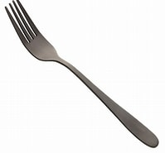 4. ball
20.  5. fork.
21. fill these words in the following sentences. / 8marks

clay, computer , sand soil , moderate wind , breeze wind.

1. ……………………………is type of wind that shake trees and sorroundings
2. when modeling decorations ………………………………………….soil is mixed with fine sand.
3. ……………………………….is ICT tools used in daily life.
4. ………………………………………is type of soil used to make building material.
5. a. give three (3) domestic animals. / 6marks

……………………………………………………………………………………………………………………………

b. give two (2) wild animals.

………………………………………………………………………………………………………………………………….

1. identify two(2) toys you can make in paper. / 2marks

…………………………………………………………………………………………………………………………………..

1. put tick for bedroom materials and cross 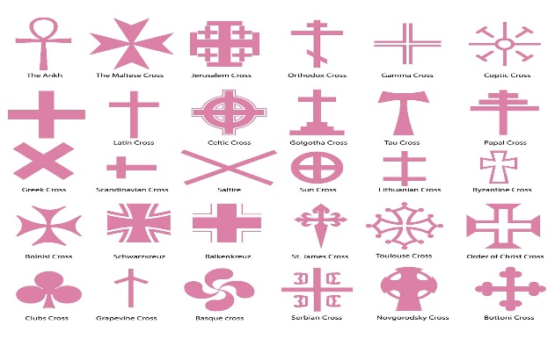for agriculture tools /4marks
2. wheelbarrow
3. a matress
4. a forkedhoe
5. a mosquito net