REPUBLIC OF RWANDA.

GATSIBO DISTICT **PAPER II**

SCHOOL………………………………………………………….

NAMES…………………………………………………….

CLASS……………………………………………………..

P2 END OF SECOND TERM.

SCIENCE ELEMENTARY TECHNOLOGY.

DURATION:2HRS.

INSTRUCTION:

* All questions are compulsory
* Don’t open this question until you are told to do so.
* Read each question carefully before answering it.
* Use only a blue or black pen

1. Circle correct word to complete the sentences/20marks

a) ……………………is colorless liquid

i) water, ii, pen iii) computer

b) We use ………………at school to take notes

I)Duster ii) fork iii) pen

c)………………………is cultivated plant

i)black ii) beans iii) black berries

d……………….is study of living things and non- living things

I, ICT ii, science

E, we use …………….at home in dining room

I, plate ii, bag iii, computer

1. Classify give animals into domestic animals and wild animals./20marks

Lion, pig, cow, elements, cat, snake, gorillas, goat, tiger, rabbits.

|  |  |
| --- | --- |
| Domestic animals | Wild animals |
|  |  |

1. Match ICT tools and its names/20marks

i. radio

a. 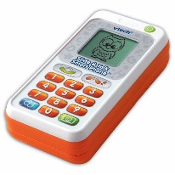

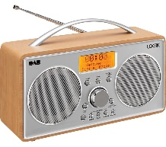 ii. microphone

 ii. Telephone

 iv. Computer

1. Mention any five tools we use at school/20marks

i…………………………………………………ii…………………………………………………………………iii……………………………………iv………………………………………v………………………………..

5.Draw the following materials/10marks

A cup

b. Book

6.Answer True or false/10marks

a. We use telephone to call

b. Maize is non-cultivated plant

c. Rabbit is domestic animals

d. Lakes is not source of water

e. pen is ICT tool