**REPUBLIC OF RWANDA**

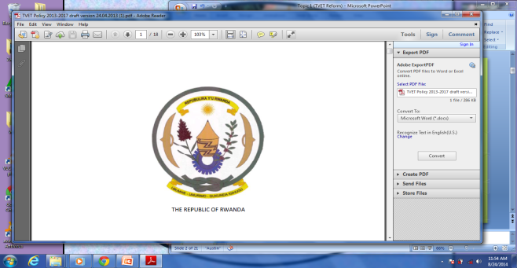

**GATSIBO DISTRICT**

**GEOGRAPHY and ENVIRONMENT**

**Class: S2**

**PHYSICAL GEOGRAPHY PAPER III**

**CLASS: S3**

**Duration: 3Hours**

**INSTRUCTIONS: This paper has THREE sections: A,B&C**

**SECTION A: Attempt all questions /55 marks**

**SECTION B: Attempt ONLY THREE questions /30 marks**

**SECTION C: Attempt ONLY ONE question /15 marks**

**SECTION A: Attempt all questions. ( 55marks)**

1) Define the term galaxy. **(1mark)**

2. (a) What do you understand by the term weather station. **(1mark)**

(b) Describe the factors that one can take into account while setting up a weather station. **(4marks)**

3. Study the following diagram showing the origin of an Earth quake and answer the questions that follow:

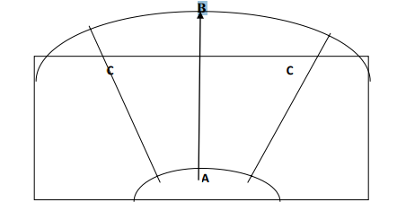

a) Name different parts **A, B** and **C.** **(3marks)**

b) Explain parts A and B. **(2marks)**

c) Identify the negative impact of earthquakes. **(3marks)**

4 a) Differentiate between folding from faulting **(2Marks)**

b) Identify the impacts of faulting on the environment. **(4Marks)**

5. a. Explain what is meant by “weathering.‟ **(1mark)**

b. Explain 3 factors influencing weathering. **(6marks)**

6. Identify the relationship between climate and the following:

a) Vegetation **(1mark)**

b) Agriculture **(1mark)**

c) Drainage **(1mark)**

7. a) Describe the causes of soil erosion and mass wasting **(5Marks)**

b) Explain the measures of controlling erosion and mass wasting **(5Marks)**

8. By using diagram show the formation of ox-bow Lake. **(4marks)**

9. a)Name the intrusive and extrusive features labeled by the numbers (1,2,3,4&5) in the diagram below. **(5marks)**

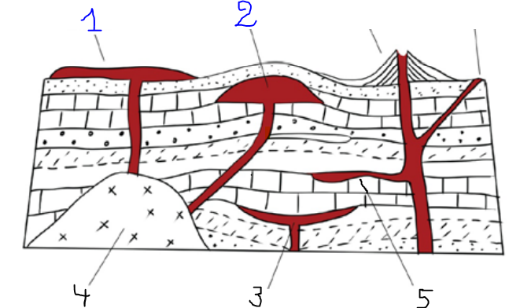

b).Explain the impact of vulcanicity on the environment. **(6marks)**

**Section B: Attempt 3 questions. (30marks)**

10.a) Define Relief **(1Mark)**

b) With examples, explain 4 types of mountains in Africa **(6Marks)**

c) Explain the influence of relief on the following activities:

i. Agriculture **(1mark)**

ii. Settlements **(1mark)**

iii. Transport and communication **(1mark)**

11. With diagrams and examples explain 5 types of lakes and their mode of formation **(10marks)**

12. a) Draw a map of Rwanda and on it mark and label lakes: Kivu, Rweru and Burera. **(4marks)**

b) Assume you are appointed the specialist of disasters in the ministry of disaster management and refugee affair in Rwanda, what measures would put in place to overcome the effects of floods **(6marks)**

13. a) Explain the challenges that Rwanda faces with in obtaining sustainable clean water. **(5marks)**

b) Supposed you have been nominated as an expert in water Sanitation Corporation, what measures would you put forward to conserve water bodies and supplying clean water to the population. **(5marks)**

**14. a)** Name the types of soil found in Virunga region **(1mark**

b) Explain four causes of soil erosion in the area mentioned in a above **(5marks)**

c) Describe different ways of keeping land from being eroded **(4marks)**

**SECTION C: ATTEMPT ONLY ONE QUESTION (30marks)**

15. Study the extract map below and answer related questions

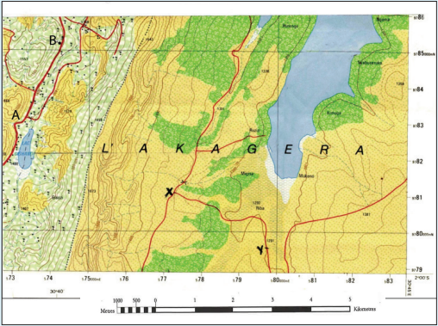

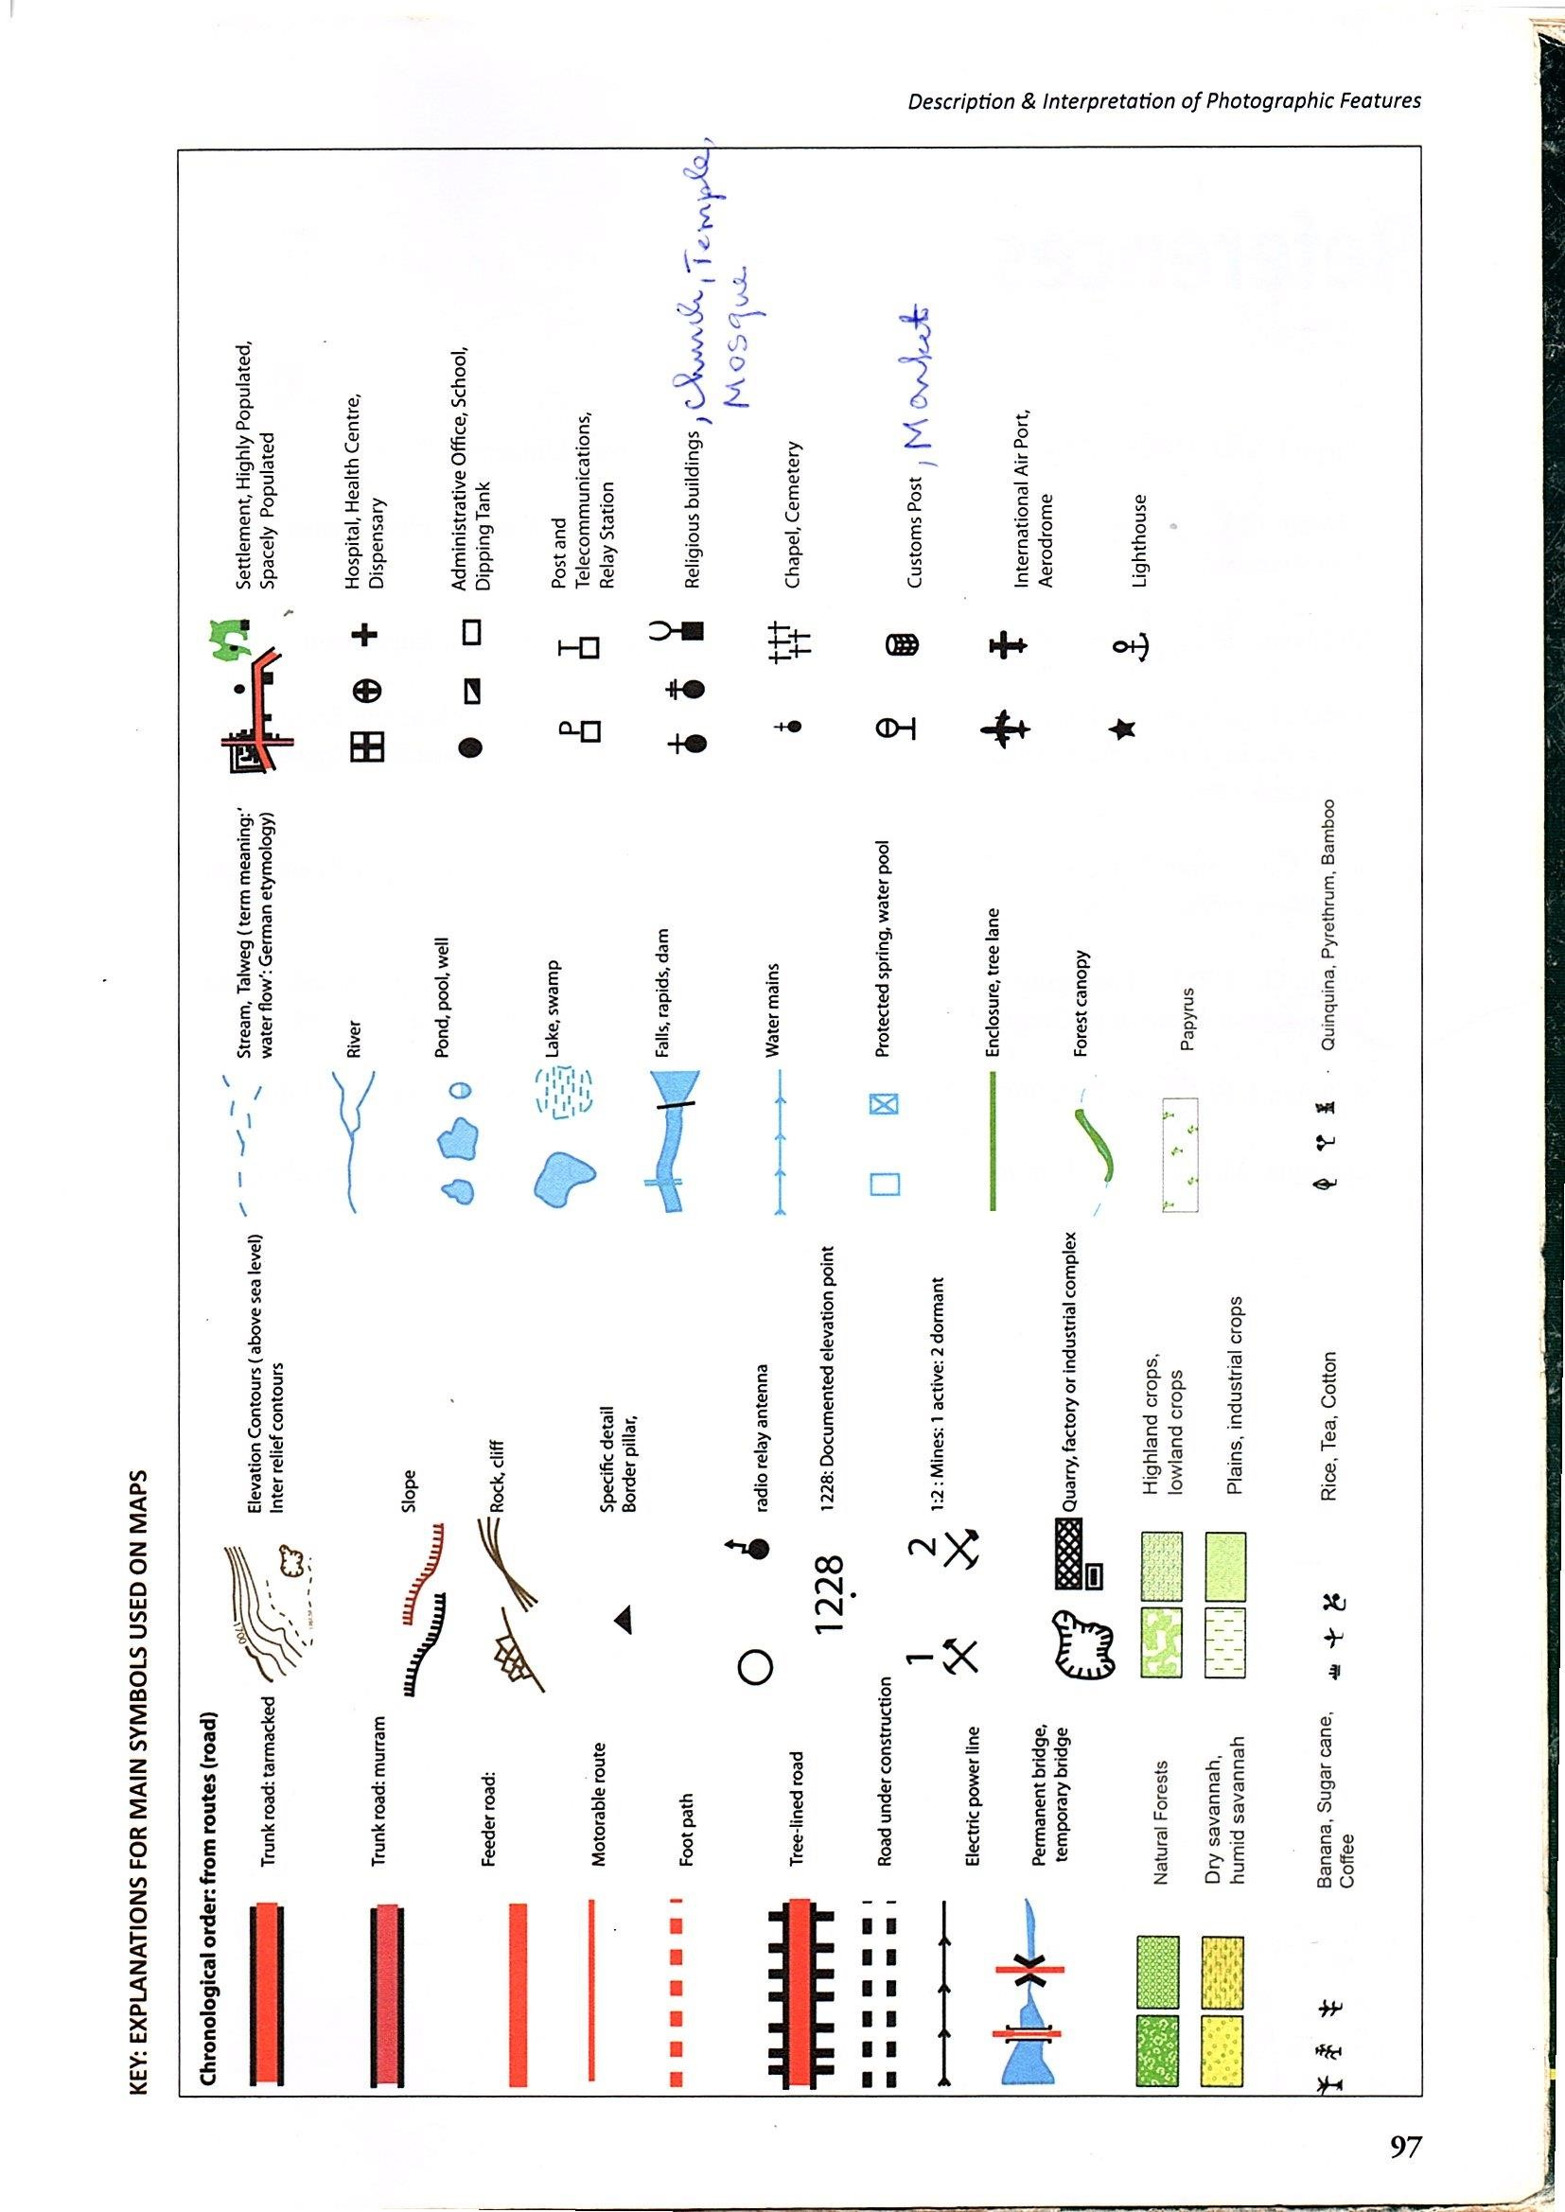

1. Determine the location of point **A** from point **B (1mark)**
2. Describe the relief features on this map **(3marks)**
3. Identify the economic activities carried out on this map and explain the reason why you choose them. **(5marks)**
4. Talk about the factors influencing and problems hindering agriculture carried out on this map **(6marks)**

16. Study the photograph shown below and answer the questions that follow:

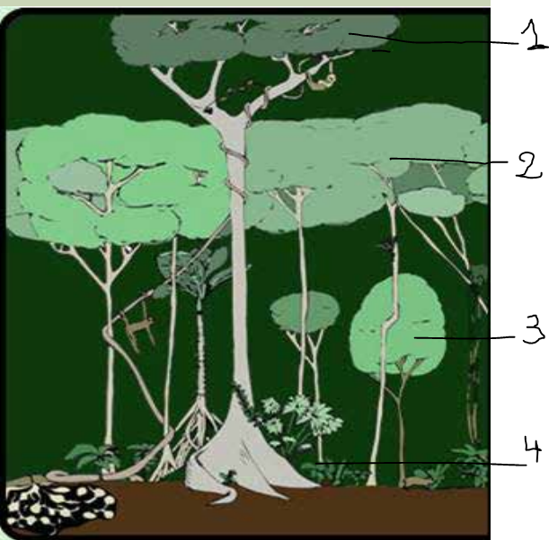

a) Which type of vegetation shown above (**1mark)**

b) Outline the economic activity carried out on the photograph (**1mark)**

c) Name the layers 1,2,3&4 of vegetation above. **(4marks)**

d) Identify any three characteristics of above vegetation. **(3marks)**

e) Explain the factors influencing vegetation (**6marks)**