**MARKING GUIDE GEOGRAPHY S3**

**SECTION A: Attempt all questions. ( 55marks)**

1. Define the term galaxy. **(1mark)**

***-A galaxy refers to the group of billions of stars held together by the same gravitational force.***

2. (a) What do you understand by the term weather station. **(1mark)**

***It is place where instrument, reading and recording of weather elements are taken***

(b) Describe the factors that one can take into account while setting up a weather station. **(4marks)**

* + ***It should be in an open ground***
  + ***The place should secured from intruders***
  + ***It should be away from the buildings, vegetation and other relief features.***
  + ***The area should experience free flow of air.***
  + ***The site should be in relatively flat area not affected by floods or any surface runoff that pose a threat to instruments and for ease of installation and reading***.

3. Study the following diagram showing the origin of an Earth quake and answer the questions that follow:

1. Name different parts **A, B** and **C.** **(3marks)**

***A= Hypocenter (focus)***

***B=Epicenter***

***C= Body wave/ Body wave***

1. Explain parts A and B. **(2marks)**

***-A=Focus or hypocenter: It is the place of the origin of the earthquake and is always hidden inside the earth.***

***-B=Epicenter is a place on the ground surface, which is perpendicular to the focus.***

c) Identify the negative impact of earthquakes. **(3marks)**

***(a) Loss of human life and destruction of property are common effects of earthquakes.***

***(b) Some powerful earthquakes cause development of violent motions in the earth making the surface look like a series of waves.***

***(c) Violent earthquakes can set off the processes of folding, faulting and even vulcanicity.***

***(d) When a massive earthquake occurs on the sea bed, it rocks the sea floor resulting in development of a very unusually powerful wave called a tsunami.***

***(e) Earthquakes are known to cause vertical or lateral displacement of parts of the land.***

***(f) Landslides are common effects after occurrence of strong earthquakes on steep areas.***

4 a) Differentiate between folding from faulting **(2Marks)**

***-Folding is the process through which the crustal rocks bend slowly upwards or downwards due to the compression forces.***

***-Faulting is the fracturing or breaking of crustal rocks which is accompanied by the vertical, horizontal and oblique displacement of the blocks caused by compressional forces and tensional forces.***

1. Identify the impacts of faulting on the environment. **(4Marks)**

***(a) Faulting causes disjointing of land. This leads to interruption of transport lines such as railways, roads and pipelines. Even construction of such lines is difficult across escarpments.***

***(b) When land subsides after faulting, many people may die in the process when buildings collapse on them or when they are buried alive in the resulting fractures.***

***(c) When faulting occurs across a river valley, it can cause a river to change its direction of flow or even disappear into the ground along the fault.***

***(d) In some regions where faulting has occurred, the fractures may extend deep down into the earth. These fractures may form easy passage for hot water or steam to come to the surface. This results into geyser and hot springs that can be harnessed for production of geothermal electricity.***

5. a. Explain what is meant by “weathering.‟ **(1mark)**

**Weathering is a breakdown of rock into small particles in situ**

b. Explain 3 factors influencing weathering. **(6marks)**

**-Relief**

**-Climate**

**-Nature of parent rock**

**-Living organisms**

**-Time**

6. Identify the relationship between climate and the following:

a) Vegetation **(1mark)**

***Tree species growing in a forest are determined by the climate of the region. There are species that thrive in hot tropical climates such as mahogany, ebony and ironwood. These would not grow in cool climatic regions. On the other hand, tree species such as pine and cypress which are exotic softwoods are indigenous in cool temperate lands.***

b) Agriculture **(1mark)**

**Heavy rain influence crops growing, while high temperature reduces agricultural production**

1. Drainage **(1mark)**

**Heavy rain increase the amount of water on the earth surface, while high temperature reduce water on the earth**

7. a) Describe the causes of soil erosion and mass wasting **(5Marks)**

***.Heavy rainfall***

***• Steep slopes***

***• Winds***

***• Drought***

***• Increase in wild game population***

**.Human activites like: mining, poor cultivation, deforestation,….**

b) Explain the measures of controlling erosion and mass wasting **(5Marks)**

***a) Afforestation***

***b) Reafforestation***

***c) Agro-forestry***

***d) Planting cover crops***

***e) Ploughing across the contours***

***f) Using soil embankments on slopes***

8. By using diagram show the formation of ox-bow Lake. **(4marks)**

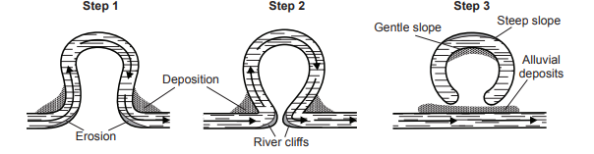

9. a) Name the intrusive and extrusive features labeled by the numbers (1,2,3,4&5) in the diagram below. **(5marks)**

***1= Lava flow***

***2= Laccolith***

***3= Lapolith***

***4= Batholith***

***5= Sill***

b).Explain the impact of vulcanicity on the environment. **(6marks)**

***-Many types of volcanic lava, upon weathering, form fertile soils which are of agricultural value and in which a variety of crops may grow.***

***-Geysers are harnessed to produce geothermal electricity.***

***-The variety of volcanic features formed attract tourists who in turn bring into a country, the much needed foreign exchange that can be used for further development.***

***-Many volcanic mountains receive relief rainfall on their windward slopes.***

***-Many varieties of igneous rocks are used in the construction industry for building roads, bridges and houses.***

***-A variety of hot springs and geysers are used by some people as health medecine. It is believed that the water and the minerals contained therein have healing effects.***

***- When volcanic eruptions occur, they may lead to loss of life and property.***

***- Some volcanic rocks weather into sandy soils that hinder brick making.***

***-The presence of a number of volcanic features becomes a barrier to construction of communication lines***

**Section B: Attempt 3 questions. (30marks)**

10. a) Define Relief **(1Mark)**

***Relief refers to the physical landscape with regard to the configuration of the surface into various landforms, and their variation in height above sea level****.*

b) With examples, explain 4 types of mountains in Africa **(6Marks)**

***-Fold moutains(The Atlas fold mountains in the North West Africa, The Cape Ranges in South Africa)***

***-Fault/Blockmountains(Rwenzori on the border of Uganda and Democratic Republic of Congo, Pare and Usambara in north eastern and Damakil Alps in Ethiopia and Eritrea)***

***-Volcanic mountains(Namuli Mountains in Mozambique and Brandberg in Namibia.)***

***-Residual mountains(inselberg mountains In eroded areas)***

c) Explain the influence of relief on the following activities:

i. Agriculture **(1mark)**

***-Gentle and valley slope influence agriculture due to fertile and well drained soil while steep slope are unsuitable for agriculture due to infeltile soil and soil erosion***

ii. Settlements **(1mark)**

***-Gentleslope are good for settlement because of are disasters free while steep and valley slope are not good for settlement due to severe disasters***

iii. Transport and communication **(1mark)**

***-Gentle slope are good for road transport due to easy construction of roads whilevalley and steep slope became barrier to roads construction***

11. With diagrams and examples explain 5 types of lakes and their mode of formation **(10marks)**

***-Lake formed due to faulting ( Rift valley or Grabben lake), example: kivu lake***

***-Lakes formed due to vulcanicity( Crater lake , Lava dammed lake) example: Burera and Ruhondo lake***

***- Lakes formed due to deposition ( Ox-bow lake) example****:****RWERU is a lake******due to******alluvial deposits/ Back ponds of a river.***

***-Lakes formed due tocrustal warping. Example: Muhazi lake***

***-Lakes formed ue to human activities ( Dams) example: Muhanga dam in kabgayi***

12. a) Draw a map of Rwanda and on it mark and label lakes: Kivu, Rweru and Burera. **(4marks)**

b) Assume you are appointed the specialist of disasters in the ministry of disaster management and refugee affair in Rwanda, what measures would put in place to overcome the effects of floods **(6marks)**

13. a) Explain the challenges that Rwanda faces with in obtaining sustainable clean water. **(5marks)**

* ***The increase in population in the rural areas which are also the sources of water has led to interference with the natural water sources***
* ***Careless discharge of wastes into water bodies***
* ***Climatic changes***
* ***Poor land use methods which leads to soil erosion***
* ***Reclamation of wet lands***
* ***Encroachment on catchment areas***
* ***Improper sanitation***

b) Supposed you have been nominated as an expert in water Sanitation Corporation, what measures would you put forward to conserve water bodies and supplying clean water to the population. **(5marks)**

***Resettlement scheme***

***Re-allocation of people from water bodies***

***Conservation of wetland***

***Carrying out environmental education***

***Population control measures***

***Construction of planned drainage systems***

***Proper urban planning***

***Proper disposal of garbage***

***Recycling of wastes***

***Afforestation and reforestation***

***Enforcement of laws to protect the environment***

***Construction of valley dams***

**14. a)** Name the types of soil found in Virunga region **(1mark**

**Volcanic soil**

b) Explain four causes of soil erosion in the area mentioned in a above **(5marks)**

***.Heavy rainfall***

***• Steep slopes***

***• Increase in wild game population***

***-Deforestation***

***Agriculture on slope***

c) Describe different ways of keeping land from being eroded **(4marks)**

***a) Afforestation***

***b) Reafforestation***

***c) Agro-forestry***

***d) Planting cover crops***

***e) Ploughing across the contours***

***f) Using soil embankments on slopes***

**SECTION C: ATTEMPT ONLY ONE QUESTION (30marks)**

15. Study the extract map below and answer related questions

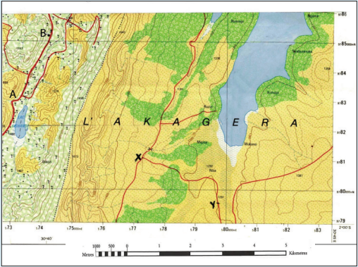

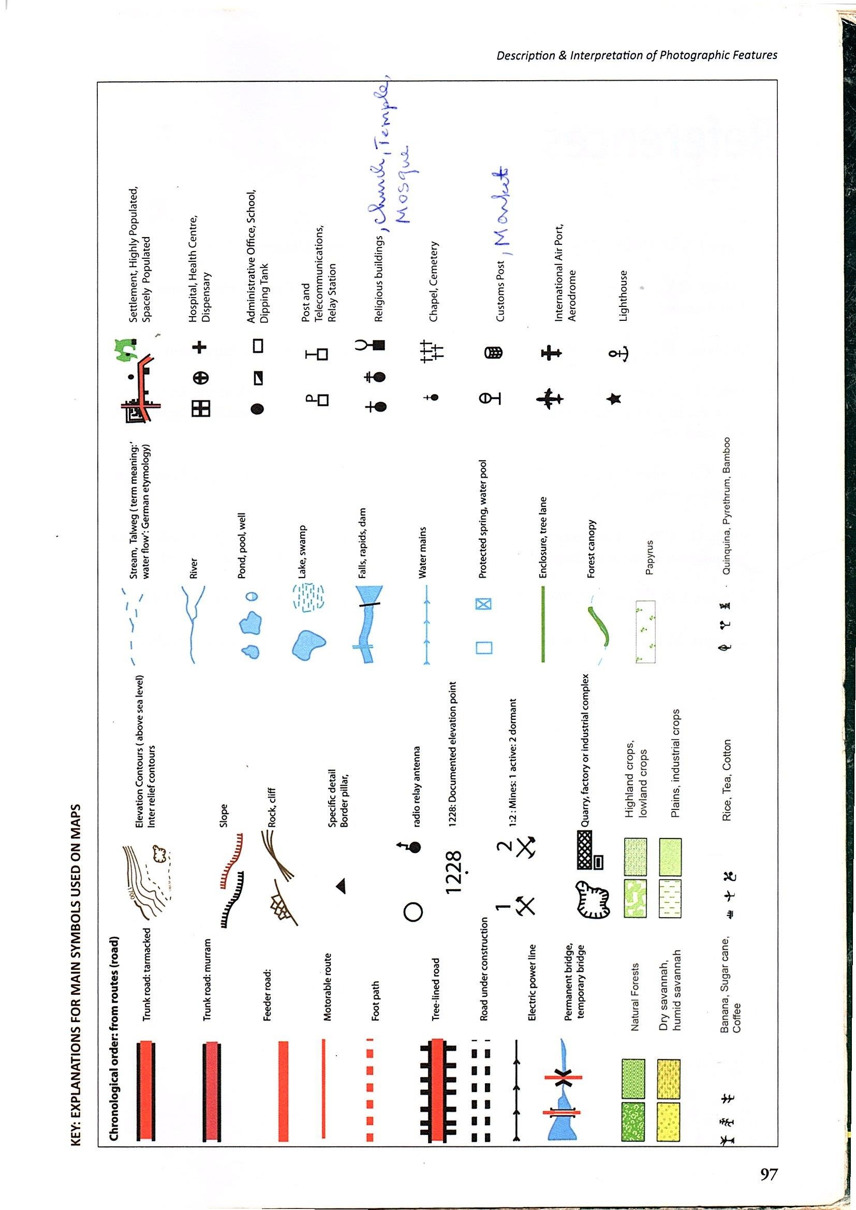

1. Determine the location of point **A** from point **B (1mark)**

***A is located in the southwest of B***

1. Describe the relief features on this map **(3marks)**

***Relief in western part is steep because contours are close; while at eastern part relief is valley because contours are away from each other***

1. Identify the economic activities carried out on this map and explain the reason why you choose them. **(5marks)**

***-Fishing***

***-Agriculture***

***-Water transport***

***-mining***

***-tourism***

1. Talk about the factors influencing and problems hindering agriculture carried out on this map **(6marks)**

***-Factors influencing***

***Availability of water***

***Availability of fertile soil***

***Availability of Means of transport***

***Availability of Capital***

***Availability of Labour***

***Availability of market***

***-Problems hindering***

***Flooding***

***Pest and diseases***

***Lack of Capital***

***Lack of Labor***

***Lack of market***

16. Study the photograph shown below and answer the questions that follow:

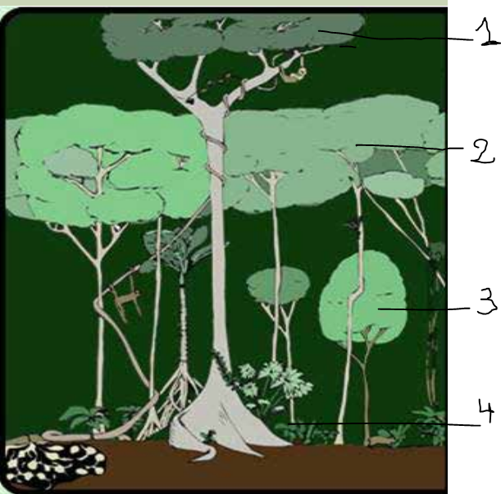

a) Which type of vegetation shown above (**1mark)**

***Equatorial or Tropical rain vegetation***

b) Outline the economic activity carried out on the photograph (**1mark)**

**-Lumbering**

**-Tourism**

**-Forestry**

c) Name the layers 1,2,3&4 of vegetation above. **(4marks)**

**1= Emergent layer**

**2= Canopy layer**

**3= Understory layer**

**4= Shrubs layer**

dIdentify any three characteristics of above vegetation. **(3marks)**

***-Temperature are high throughout the year with an average of 26oC***

***-Annual temperature ranges rarely less than 5oC***

***-Abundant and regular rains with thunder, strong winds(1500-2500mm).***

***-Days and night are almost equal.***

***-There is a fairly large amount of cloudiness.***

***-The Equatorial regions lie in a belt where the winds are light. It is a lowpressure belt.***

***-High relative humidity of about 80%***

***-Absence of distinct dry season***

e) Explain the factors influencing vegetation (**6marks)**

**-Relief**

**-Climate**

**-Human activities**

**-Biotic factors**

**-Soil fertility**

**-Government policy**