**REPUBLIC OF RWANDA**

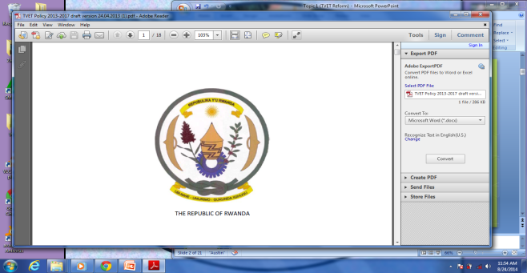

**GATSIBO DISTRICT**

**GEOGRAPHY and ENVIRONMENT**

**Class: S2**

**CLASS: S1**

**Duration: 3Hours**

**INSTRUCTIONS: This paper has TWO sections: A&B**

**SECTION A: Attempt all questions /55 marks**

**SECTION B: Attempt ONLY THREE questions /45 mark**

**SECTION A: Attempt all questions /55 marks**

1. Differentiate the two branches of Geography. /2mks

2. Name at least 3 sources of geographical information./3mks

3. a) Define the term a map. /1mk

b) List any 5 elements of a good map. /5mks

4. a) What is a slope. 2mks

b) Identify the types of slopes. / 4mks

5. With examples distinguish between a constellation and galaxy./4mks

6.a) Name two earth’s movements. /2mks

b) Identify the consequences of the revolution of the Earth. /6mks

7. a) Write in full the following mineral components

i) SIAL (2mks) ii) SIMA (2mks)

b)Distinguish between the MOHOROVICIC and the GUTENBERG discontinuities/4mks

8. a) Name the relief features found in Rwanda. /4mks

b) Explain how the relief features of Rwanda influence human activities/6mks

9. a) Define a rock. /2mks

b) Give the characteristics of igneous rocks. /3mks

c) Explain how igneous rocks are formed. /3mks

**Section B:Answer only THREE questions (45mks)**

10. Using specific examples explain the importance of rock to the economy of Rwanda. /15mks

11.Explain five differences between a map and aerial photographs/15mks

12. Explain the importance of studying geography in Rwanda. /15mks

13.a) Earth is among the eight planets in the solar system ,

and is unique. Explain why? /3mks

b) Explain the components of the external structure of the Earth./8mks

c) List 4 characteristics of the moon. /4mks

END!!!!!!!!!!