**MARKING SCHEME FOR PROPOSED DISTRICT PHYSICS EXAM FOR S2/2022-2023.**

**MARKING GUIDE PAPER I**

|  |  |  |  |
| --- | --- | --- | --- |
| **Question** |  | **Answer** | **Marks** |
| 1 | A |  | **2** |
| 2 | C |  | **2** |
| 3 | B |  | **2** |
| 4 | C |  | **2** |
| 5 | C |  | **2** |
| 6 | D |  | **2** |
| 7 | C |  | **2** |
| 8 | D |  | **2** |
| 9 | C |  | **2** |
| 10 | A |  | **2** |
| 11 | B |  | **2** |
| 12 | D |  | **2** |
| 13 | D |  | **2** |
| 14 | A |  | **2** |
| 15 | C |  | **2** |

16. U= 0m/s , V= 20m/s time = 5seconds

a) A= = = 4m/s2 **(2.5 marks)**

b) a= = = - 2.5 m/s2**(2.5marks)**

17. a) ) Lever, screw , wheel and axle , inclined plane , pulley and wedge**(5marks)**

b) VR = 4 , E = 75%

i) M.A = $\frac{E X VR}{100\%}$ = $\frac{75 X 4}{100}$ = 3**(3marks)**

ii) effort = 500N

M.A = $\frac{load}{effort}$

Load= M.A x Effort = 3x 500 = 1500N**(3marks)**

iii) Work done = Load x distance = 1500x4 = 6000J**(3marks)**

iv) Rate of working = work done/time = 6000J/1200s = 5 watts**(3marks)**

18. a) Forms of energy **(4marks)**

Sound energy , solar energy, nuclear energy. Mechanical energy , Heat energy , Electrical energy, Chemical energy

b) The law of conservation of energy states that energy cannot be created or destroyed but is simply converted from one form into another**.(2marks)**

c) Kinetic energy : It is the energy possessed by a body due to its motion. K. E = ½ MV2 **while**

Potential energy : It is the energy possessed by a body due to its position. P.E = mgh**(2marks)**

d) mass = 400 kg , h= 2.3m v= 3m/s

i) P.E = mgh = 400x10x2.3= 9200J**(2marks**)

ii) K. E = ½ mv2 = ½ x 400 x 32= 1800 J**(2marks)**

19. a) **Centre of mass:** is the point at which the distribution of the mass is equal in all directions and does not depends on gravitational field.**OR** Centre of mass of an object on the other hand is the point where all the mass of the object is concentrated While **The centre of gravity:** is the point at which the distribution of weight is equals in all directions and does not depends on gravitational field . or the point through which its total weight acts.**(4marks)**

b) It is because centre of gravity of taller person is higher than that of the shorter person.**(2 marks)**

c) **Determination of centre of gravity (c.o.g) of irregular lamina**

**(6marks)**

APPARATUS

1. Cardboard of different shapes
2. Thread
3. Nail
4. Pencil
5. Rulers/Straight edge
6. Load (stone ,wood etc)

PROCEDURES

Cut an irregular shape from the cardboard

1. Make three holes closer to the edge of irregular shaped cardboard
2. Attach a string on a point of a cardboard suspend it.
3. If the cardboard is in equilibrium draw a line on it a vertical line that coincides with the string.
4. Repeat steps iii and iv for the remaining holes making the position of the plumblines carefully.
5. Locate the intersection of the three lines drawn : this indicates the centre of gravity of the object.

20 ) a) Energy is the ability to do work.**(2marks)**

b) work is the product of force and distance**(2marks)**

c) Power is the rate of doing work**.(2marks)**

d) weight = 300N , height = 5m time = 10 seconds

Power = work/time taken, work = F X D= 300x5 = 1500J

P = W/T = 1500/10 = 150 Watts**(3marks)**

21.

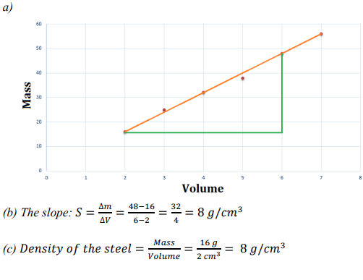

**(10 marks)**

**(3marks)**

**(2marks)**

……………………………….**END………………………………..**