**MARKING SCHEME FOR PROPOSED DISTRICT PHYSICS EXAM FOR S2/2022-2023.**

**SECTION A**

1. Force

Pa

N/m2

F/A

6Pa

Increased

LT-1

ML-1T-2

1. A) Motion

b)Nature

c)unnecessary heat

d)reduces

e) Less

3. A. Because as the Area decreases , pressure increase.

4. a) mass, Length, pressure and Temperature

b) Force and acceleration

5. a) (iii)

b)(iii)

c) (i)

d) (i)

e) (iii)

g)I) (iii)

II) (iv)

6. v= u+ at

t= (v-u)/a

t=(35-10)/5

t=5s

7. Shema, Because weight of body: The higher the weight of an object the higher the friction force it is.

8. P= density x acceleration due to gravity x height

(13600x9.8x0.72) = 96059pa

9. The cardboard does not fall and the water remains in the glass even though it's not supported by anything. This is because the force caused by the atmospheric pressure acts on the surface of the cardboard is greater than the weight of the water in the glass. This experiment proves that atmospheric pressure is present on the surface of the earth.

10. a) w= force x distance

=20NX5m

= 100J

b) P= work/time

=100J/1s

= 100Watts

**SECTION B**

**11. A**pplications of atmospheric pressure are

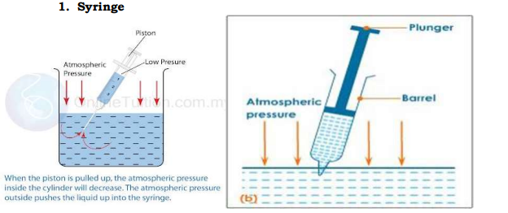

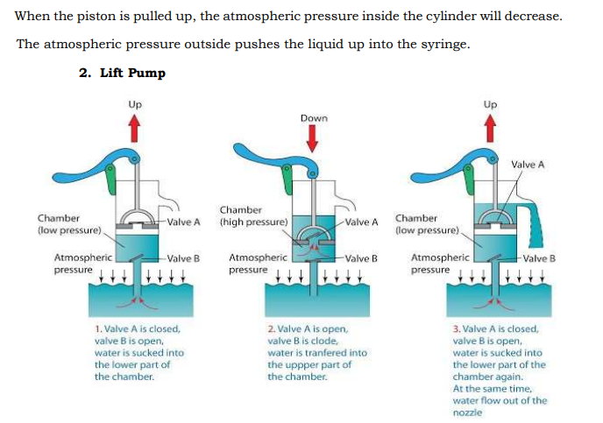

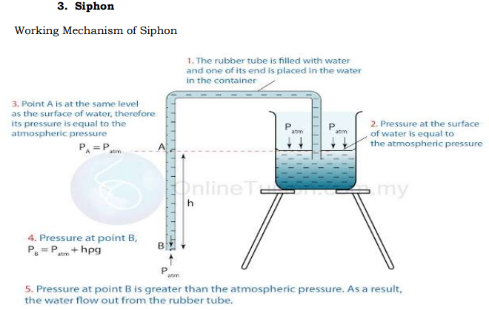

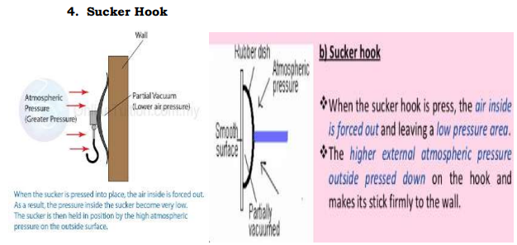

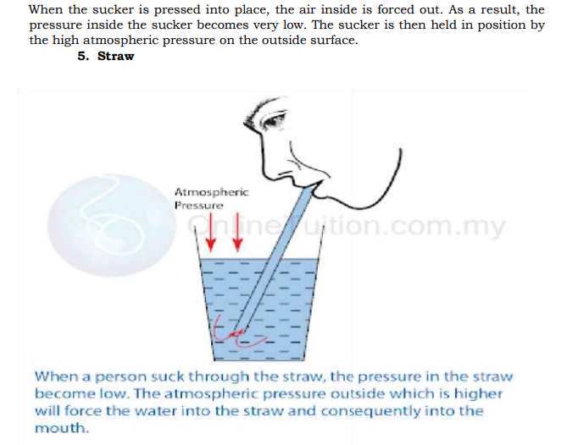12. 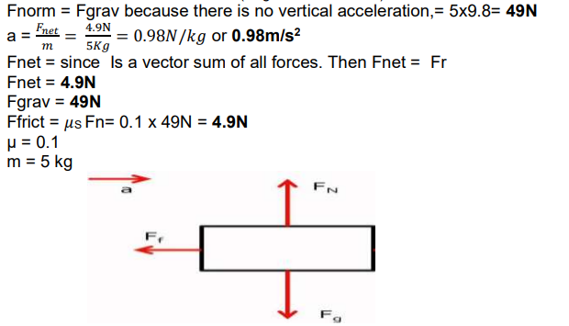

13.

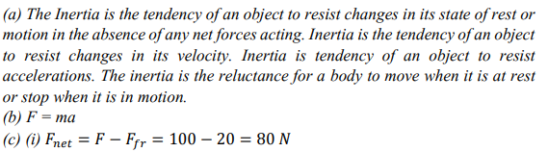

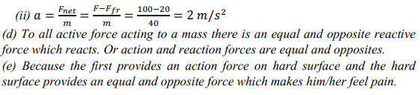

14. 

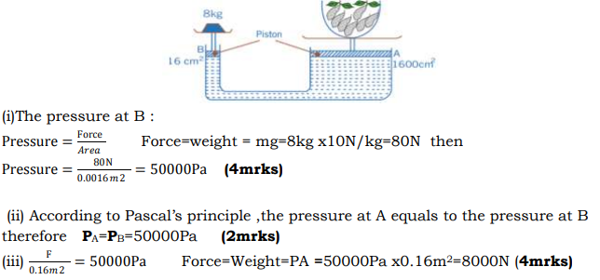

15.

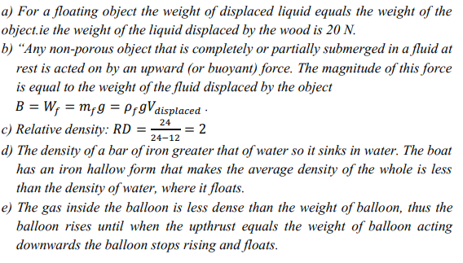



16.

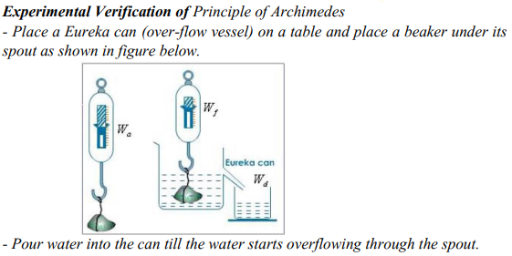

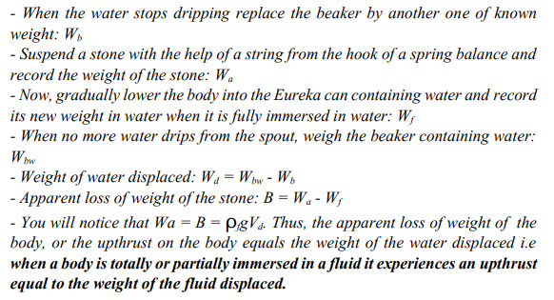

………………………………………………………………END……………………………………………………