**CHEMISTRY SENIOR 3**

**Marking guide for senior three paper 1**

1. a) element is Sulphur with 16, electron configuration is 2:8:6 / 2marks

b) Z = 16 / 1mark

c) Protons are 16 / 1mark

d) electrons of ion X2- are 18 / 1mark

e) S + O2= SO2 or XO2 / 1mark

1. a) Chemical or natural substances added to soil or land to increase its fertility. / 2marks

b) . It necessary to apply fertilizers into the soil in order to increase the agriculture products or harvests / 1mark

c) HNO3 and KOH / 1mark

3.i) C4H3O /2mark

ii)C16H12O4 / 2marks

4.i. Allotropes are the existence of an element in two or more forms. /1mark

ii. -use of diamond: it can use to cut glasses and hard metals, jewelry

- use of graphite: it uses to make lead pencil, lubricating / 2marks

iii. Diamond is hard, not conduct heat and electricity

Graphite is soft, good conduct of heat and electricity. / 4marks

5. a) i) Sodium phosphate = Na3PO4 **/ 1mark ii)** Aluminum oxide =Al2O3 / 1mark

**iii)** Zinc chloride = ZnCl2 / 1mark

**b) i) Ozone layer protect the human skin UV light which are very dangerous for human and can cause skin cancer. / 2marks**

**ii) Chemical substance that destroy ozone layer are CO2 and SO2 / 2marks**

iii) S (s) + 2Na= Na2S / 2marks

6. a) Concentration of solution is the amount of solute that dissolved in solution/ 2marks

b) Increasing pressure for gaseous reactants, there are more reactant particles collisions and rate of reaction is increased. /2marks

7. V1= 90ml/ second; M1= x

V2= 102ml/ second; M2= 44g/ mole

V1/ V2= √M2/M1,

90/102=√44/M1

0.882=√44/M1,

0.7779= 44/M1

M1= 44/ 0.7779

M1= 56.56g/ mole 0r M1=57g/mole / 2marks

8. a. Monoclinic and rhombic / 2marks

b. Does no conduct electricity except graphite

not ductile and malleable / 2marks

9. a) Percentage of hydrogen in hydrogen peroxide



= 5.9% / 1mark

Percentage of oxygen in hydrogen peroxide

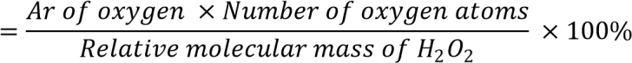

= 94.1% / 1mark

b) Molar mass of Fe2O3=160g/mol

mass is 160g/mol x 5= 800g / 2marks

c) n= number of particles / Avogadro’s number, molecules= 0.1806x 10^23 molecules / 2marks

10. a. Ca (OH)2 + 2NH4Cl = CaCl2 + 2H2O + 2NH3 / 2marks

b. Because H2SO4 can react with ammonia while CaO cannot react. / 1mark

c. i. Eutrophication: is sudden growth of aquatic plant due to excess of fertilizers in water bodies / 1mark

ii. Death of aquatic animals, water pollution / 1mark

SECTION B:

11. a. NaCl + H2SO4 = Na2SO4 + HCl or NaCl + H2SO4 = NaHSO4 + HCl / 2marks

b. it has role of drying the HCl gas / 1mark

c. physical properties of HCl gas: it is colorless, is danse than air and has pungent smell / 2marks

d. Mg + 2HCl = MgCl2 + H2 (g) / 2marks

e. 2KMnO4 + 16 HCl = 2KCl + 2MnCl2 + 8H2O + 5Cl2. / 2marks

f. CFCs destroyed the ozone layer / 1mark

12.

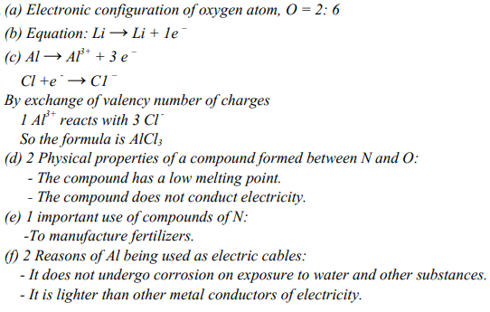

13.a. Step1: S+ O2= SO2

Step2: SO2 + O2 = SO3, with the presence of V2O5 and temperature between 450 and 5000C

Step3: SO3 + H2SO4 = H2S2O7 (Oleum)

Step4: H2S2O7 + H2O= 2H2SO4. / 8marks

b. it used in car batteries, making fertilizer, dry gas, making dyes / 2marks

14.

H2SO4 (aq)+ 2NaOH(aq) 2H2O(l) + Na2SO4 (aq)

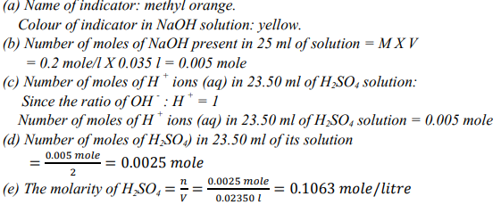

**SECTION C:**

15. a. CaCO3 + HCl = CaCl2 + CO2 + H2O

b. water in the first wash bottle is used to remove sprays of hydrochloric acid (hydrogen chloride gas) and sulphuric acid is used to dry gas

**c.** because it is denser than air.

d. there is no carbon dioxide

e. There is formation of CaCO3

f. Test for CO2: we use Ca(OH)2 added into CO2 to produce white ppte of CaCO3, formation of milk solution. With excess of CO2, the insoluble ppte turns soluble colorless.

g. Respiration and photosynthesis

h. Global warming, air pollution

i. Afforestation, minimize use of fuel in vehicles by using electrical cars.

16.

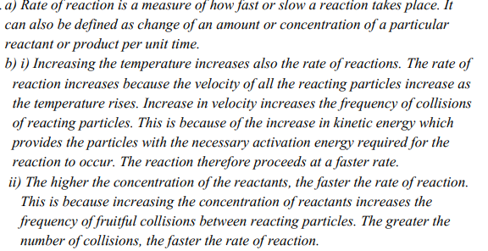

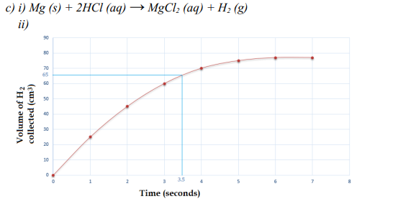

iii. the volume of hydrogen evolved at 3.5 seconds = 65Cm3

iv. the reaction ends at 6 seconds.

END