**Chemistry senior two 2023**

**Marking guide for senior two copy1**

1. a) Bond is a force of attraction which holds together two or more atoms.

b)**Ionic bond** is a strong electrostatic force of attraction that exists between ions of opposite charge. It is formed between a metal and a non-metal. Then there is transfer of electrons from metal to non-metals

**Covalent bonding** is a strong electrostatic force of attraction between metallic atoms.

It can also be defined as a bond formed when non-metallic elements share a pair of electrons.

A **metallic bond** is the electrostatic force of attraction between the positive core and the sea of electrons.

1. a.Ca: 2: 8:8:2

b.i. CaCl2ii. Al2O3 iii. Ionic bond

c. i. Mg -2e = Mg2+

ii. Cl +1e = Cl-

1. a. number of moles = number of particle / 6. 023x 10^23,

Number of mole= 0.019moles.

b. mass= n x Ram of Fe= 0.019 x 56= 11.144g.

1. a.2Na + Cl2 = 2NaCl

b. MgO + 2HCl= MgCl2 + H2O

c. C + O2= CO2

d. 2K + H2SO4= K2SO4 + H2

e. NaHCO3 + HCl= NaCl + CO2 + H2O

5.a. Cl- + AgNO3 = AgCl ( whiteppte), Br- + AgNO3 = AgBr (yellow ppte)

b. Fe2+ = green, Fe3+ = red-brown, reagent is NaOH

6. a. Endothermic reaction: absorb energy from surrounding

Exothermic reaction: give out the energy to the surroundings

b. exothermic reaction

7. a. H+(aq) + OH-(aq) = H2O(l)

b. Mg(s) + 2H+(aq) = Mg2+(aq) + H2(g)

8. a. for the soil: It also leads to the reduction of fertile cultivatable land in the form of dumping sites.

They can be dangerous to the aeration system of the soil and binder agriculture.

For water: it leads to the death of aquatic animals, it contributes to water

Pollution

9. The difference diseases like cholera, diarrhea, typhoid

10. Graphite has free electrons move while diamond not has free electrons

11. Prevention of water pollution through education: the people educate the danger and consequence of water pollution; this can be done in schools, churches, community work like umuganda, hospitals.

12. a. Waste management includes all the processes of handling waste and reducing it.

b. Prevention, Minimisation, Reuse, Recycling, Energy Recovery, Disposal

13. a. Mm of glucose = 180

b. % of sodium = 74. 19%

14. a. Aluminium phosphate

b. Magnesium oxide

c. Potassium fluoride

d. Sulphuric acid

e. Potassium hydrogen sulphite

15. a. Decomposition

b. combustion

c. neutralization

**SECTION B:**

16. a. Y= 2: 8:1

b. Period of Y= 3, Group I

c. Ionic bond

d. YX

e.

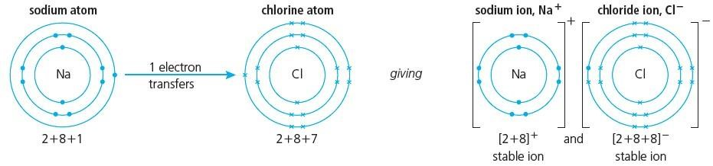

f. Covalent bond, because of all are non-metals elements

17. a. i. 4shells

ii. 1

b. i. W

ii. V

c. i. The across the period the reactivity of metals decrease due to nuclear charge increases and the across the period the reactivity non-metal increases

ii. Down the group the reactivity increases for metals, for non-metals decreases.

18. a.

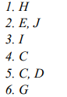

b) i. Sodium hydrogen carbonate

ii. Carbon sulphide

c. i. (NH4)2SO4

ii. Al(OH)3

19.

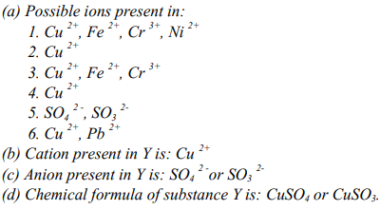

END.