**Chemistry senior one 2023**

**Marking guide for senior one copy1**

1. a. Isotopes : Are the elements of the same atomic number but different mass number.

b) Ion: Is an atom that loose or gain one or more electrons.

c) Cation : It is a positive charged atom.

d) Element ; It is type of matter composed of atoms that all have same atomic number.

e)A compound : Is a substance that consist of two or more elements chemically combined togethers

b) i) K

ii) Na

1. a) Metallic character down the group increase , because tendency of element to lose electrons increase.

b)Non-metallic character across the period increase, tendency of element to gain electrons increase.

1. a) Use to stop fire

b) used to wash

c) It is used to hold, heat and mixing small amount of liquid

d) Used to store heat, and measure volume of liquid.

1. Luminous flame Bunsen burner

Non luminous flame Bunsen burner

1. a) Matter : Is anything that occupies space and has mass.

b) Solid, liquid and gas

c) Solid : books, chalks trees , salts and stone

Gas ; Air

Liquid: Milk and water

6. Do not enter the laboratory without the teacher’s permission.

Do not run while in the laboratory because you may trip, fall and injure yourself or others in the laboratory.

Be polite while in the laboratory; do not push, scramble or fight.

Never taste or eat anything in the laboratory as these may cause poisoning or infection.

Always consult your teacher before trying out any experiment, handling apparatus or chemicals to avoid accidents.

1. Chemical engineering , Chemistry teaching , Veterinary and human medicine ,Pharmacy ,Working in a laboratory and Nutrition
2. a) Pure substance: Is a substance compose by identical component while mixture : is a substance composed by two or more components

b) Water and oil

Water and sand

c) i) Fractional distraction

ii) Magnetic separation

iii) Decantation

1. a) chemical change

b) physical change

c) Chemical change

d) Chemical change

e) physical change

10. a) sodium suphide

b) Magnesium carbonate

c) Aluminium chloride

d) Water

e) carbon monoxide

11. a) B

b) E

c) A

d) C

.12

|  |  |  |  |
| --- | --- | --- | --- |
| Sub atomic particle | Symbol | Charge | Location |
| **Electron** | **E** | -1 | **shell** |
| Neutron | **N** | **0** | **Nucleus** |
| **Proton** | **P** | **+1** | Nucleus |

13. a) Neutron= 12

Electron= 11

b) Period=3

Groups=I

C) Valency =1

14. a) Under ground water

Surface water

Rain water

b) Calourless, odourless,testless

15.

|  |  |  |
| --- | --- | --- |
| Elements | Symbols | Valencies |
| Argon | Ar | 0 |
| Beryllium | Be | 2 |
| Carbon | C | 4 |
| Aluminium | Al | 3 |
| Sodium | Na | 1 |
| Chlorine | Cl | 1 |

16.a) Water cycle is the continuous circulation of water from water bodies to the atmosphere and back to the land and water bodies.

b)

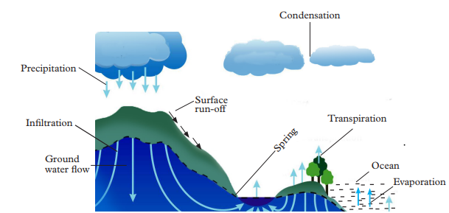

c) It regulates weather and climate of a place.

It brings about cooling of living things.

It purifies water

17. Match the following separating method with their application.**( 2marks of each)**

i) Fractional distraction 1. Obtaining butter from milk.

ii) Evaporation 2. Separation of water and ethanol.

iii) Simple distraction 3. Separation of dyes in black ink.

iv) Paper chromatography 4. Obtaining pure water from sea water

v) Centifugasion 5.Obtain salts from its solution in water

18. a) P, S

b) P, Q and R , also S and T

c) i) Because outer most shell contain one electron

ii)Because , they have the same energy level (shells)

d)Metals : P and S

e) Metalloids: T Non- metal: R and Q

END