**MINEDUC Date: …./ 03/ 2023**

**GATSIBO DISTRICT Duration: 3Hours**

**ACADEMIC YEAR:2022/2023**

**SECOND TERM**

**LEVEL: ORDINARY LEVEL MAX: 100Marks**

**CHEMISTRY EXAMINATION SENIOR THREE**

INSTRUCTIONS:

* **THIS EXAMINATION IS COMPOSED OF THREE SECTIONS.**
* **ATTEMPT ALL QUESTIONS IN SECTION A /55 MARKS**
* **CHOOSE THREE QUESTIONS IN SECTION B /30 MARKS**
* **CHOOSE ONE QUESTION IN SECTION C /15 MARKS**
* **PERIOODIC TABLE IS NOT ALLOWED**

**SECTION A: Attempt all questions.**

1. An atom of element has $\frac{A}{Z}X$. This atom belongs to group VI and period III of the periodic table.
2. Give the electronic configuration of atom X. /**2mark**
3. Find Z **/ 1mark**
4. How many protons does this atom have? **/ 1mark**
5. How many electrons does the ion X2- have? **/1mark**
6. Write the chemical formula of product formed when X react with oxygen / 1mark
7. Compounds of P, N and K are often used as inorganic fertilizers.
8. Explain what is meant by a fertilizer. / 2mark
9. Why is it necessary to apply fertilizers into the soil? / 1mark
10. Give two compounds that could be used to prepare potassium nitrate fertilizer. / 1mark
11. A compound has the following composition, 69.42% carbon, 4.13% hydrogen and the rest oxygen. / 4marks
12. Determine the empirical formula of the compound
13. If the relative molecular mass is 242, determine its molecular formula.
14. Carbon is an element found in nature under different allotropes among which there are Diamond and Graphite.
    * 1. Define allotropes. /1mark
      2. Mention one use for each form. /2marks
      3. Make a comparison between Diamond and Graphite. /4marks
15. The following list shows the chemical formulae of some ions: Na+, Al3+, Zn2+, Cl-, PO43- and O2- .

a) Use the list to write down the chemical formulae of:

1. Sodium phosphate. /**1mark**
2. Aluminium oxide. /**1mark**
3. Zinc chloride. /**1mark**

**b)** In the upper atmosphere, there is a layer of ozone surrounding the earth.

1. Explain the importance of this layer in terms of human health. /**2marks**
2. State the chemical substance that destroy the ozone layer. /**2marks**
3. Write a balanced chemical equation for the reaction between Sulphur and sodium. /**2marks**
4. a) What does it mean concentration of solution? / 2marks

b) Rate of reaction have 6 factors that will affect in chemical reaction, briefly explain how pressure will affect rate of reaction / 2marks

1. A gas of known identify as K diffuse at a rate of 90ml/ second in a diffusion apparatus in which carbon dioxide diffusion at a rate of 102ml/ second. Calculate molar mass of gas (molar mass of CO2= 44g/ mole)/ **2marks**

1. Sulphur in crystalline state consists of rings of Sulphur molecules of formula S8
2. State names of 2 allotropes of Sulphur that exist in crystalline form / 2marks
3. Sulphur is a non-metal, indicate 2 physical properties of non- metals. / 2marks

9. a) Calculate the percentages (by mass) of hydrogen and oxygen present in hydrogen peroxide (H2O2). (Atomic number mass: H=1, O=16). / 2marks

b) Calculate the mass of 5moles of Fe2O3 / 2marks

c) How many molecules are contained in 4.8 g of Fe2O3? (1 mole contained 6.02x1023 molecules). (Atomic mass of Fe = 56, O= 16)/ 2marks

10. Ammonia gas is prepared by heating calcium hydroxide and ammonium chloride. The gas is dried by passing it over calcium oxide.

1. Write a balanced chemical equation for the reaction between calcium hydroxide and ammonia chloride. /2marks
2. Why is ammonia gas not dried using concentrated sulphuric acid? / 1mark
3. One of the uses of ammonia is the production of fertilizers and when they are used in excess can cause eutrophication.
   * 1. Define eutrophication. / 1mark
     2. Explain the impact of eutrophication to human beings. / 1mark

**SECTION B: Choose three questions only**

11. Study the diagram below and answer the question that follow

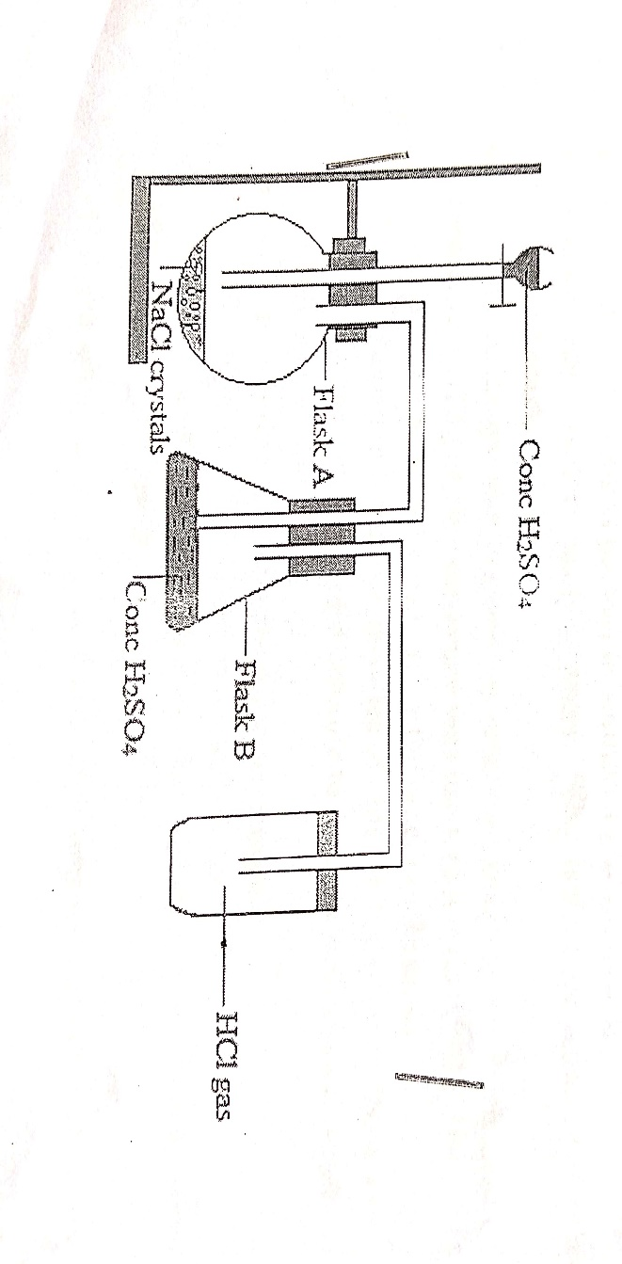

1. Write the equation of reaction between concentrated sodium chloride, NaCl solution and concentrated sulphuric acid, H2SO4 to liberate HCl gas. / **2marks**
2. State the role of concentrated H2SO4 in conical flask B. / **1mark**
3. State 2 physical properties of hydrogen chloride gas, HCl gas. /**2marks**
4. Write a balanced equation of the reaction between magnesium metal (Mg) and hydrochloric acid (HCl (aq)) / **2marks**
5. Write the equation of the reaction between concentrated KMnO4 solution and concentrated HCl acid to liberate chlorine gas, Cl2. / **2marks**
6. What is the environmental effect of the chlorine compounds like CFCs? / **1mark**
   1. The table below shows some symbols of elements of the periodic table.

Study the table and answer the questions that following:

|  |  |  |  |
| --- | --- | --- | --- |
| Atom of element symbol | Group of element | Periof of element | Atomic number |
| Li | I | 2 | 3 |
| O | VI | 2 | 8 |
| Ca | II | 4 | 20 |
| Cl | VII | 3 | 17 |
| Al | III | 3 | 13 |
| N | V | 2 | 7 |

1. Write the electronic configuration of the oxygen atom. / 2marks
2. Write a chemical equation that represents the ionization(ion formation) of Li / 2marks
3. Deduce the formula of the compound formed by reaction of Al and Cl/ 1mark
4. State 2 physical property of compound formed between N and O. / 2marks
5. Indicate 1 important use of compounds of N2 element. / 1mark
6. Give 2 reasons to sugest why Al is the best of the above elements at being used as electric cables. / 2marks
   1. a. Sulphuric acid is prepared in contact process by a chain of reactions. What are those reactions? / 8marks
   2. outline two uses of sulphuric acid in daily life/ 2marks
   3. During titration, 25ml of a 0.2mole/ litre NaOH solution was poured in a beaker. An appropriate indicator (phenolphtalein) was added to the NaOH base. Titration of H2SO4 (aq) from a burette was done. Neutralization of the base was reached on addition of 23.50ml of H2SO4 (aq) ( relative atomic mass : H= 1, O=16, S=32, Na= 23)

Equation : H2SO4 (aq)+ NaOH(aq) 2H2O(l) + Na2SO4 (aq)

* + - 1. State the name of another acid-base indicator that can be used to detect NaOH solution and the colour of this in indicator in the base . / 2marks
      2. Calculate the number of moles of NaOH present in 25ml of solution. / 2marks
      3. Determine the number of moles of H+ ions (aq) in 23.50ml of H2SO4 solution. / 2marks
      4. Determine the number of moles of H2SO4 solution at 23.50ml. / 2marks
      5. Calculate the molarity ( moles / litre ) of H2SO4 (aq). / 2marks

**SECTION C:**

* 1. Here is the preparation of Carbon dioxide in laboratory,please answer the related questions:

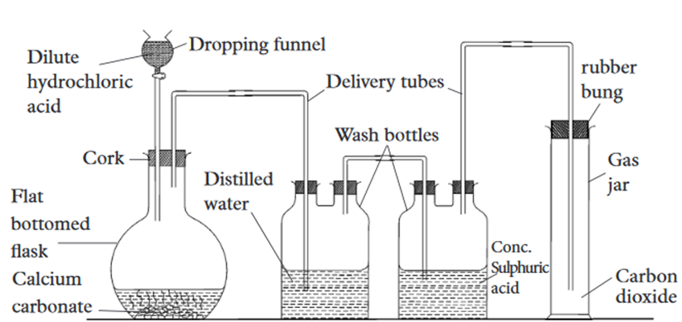

1. Write a balanced equation for the reaction that takes place in this diagram. / 2marks
2. Mention the use of distilled water and conc.Sulphuric acid in this diagram./ 2marks
3. Explain why Carbon dioxide is collected by a downward delivery method. / 1mark
4. What should happen if dilute hydrochloric acid is replaced by dilute Sulphuric acid ? / 2mark
5. What is your expectation if conc. Sulphuric acid is replaced by calcium oxide (CaO) in this diagram? / 1mark
6. To be sure that you have prepared carbon dioxide, your teacher will need to test it. Propose a chemical test for carbon dioxide that he/she will use to avoid confusion. / 2marks
7. Mention one processes that emits Carbon dioxide into the atmosphere and one processes that removes it from the atmosphere / 2marks
8. Carbon dioxide is a greenhouse gas:what should happen to our planet if there are no measures to decrease the emission of Carbon dioxide in the atmosphere ? / 2marks
9. Propose 1 measure that should be put in action by every Citizen in our country to reduce carbon dioxide emission in the atmosphere. / 1mark
   1. a. what is meant by rate of reaction?

b.Explain how the following factors affect the rate of chemical reaction:

* + - 1. Temperature
      2. Surface of the reactants

c.The table below show the volume of hydrogen gas collected at various time intervals when magnesium was reaction with 2M hyrdochloric acid.

|  |  |  |  |  |  |  |  |  |
| --- | --- | --- | --- | --- | --- | --- | --- | --- |
| Time (seconds) | 0 | 1 | 2 | 3 | 4 | 5 | 6 | 7 |
| Volume of H2 collected (Cm3) | 0 | 25 | 45 | 60 | 70 | 75 | 77 | 77 |

* + - 1. Write the chemical equation of the reaction
      2. Plot a graph of volume of hydrogen versus time.
      3. Determine the volume of hydrogen evolved at 3.5 seconds.
      4. When did the reaction end?

GOOD LUCK