**MINEDUC Date: …./ 03/ 2023**

**GATSIBO DISTRICT Duration: 3hours**

**ACADEMIC YEAR:2022/2023**

**SECOND TERM**

**CHEMISTRY EXAMINATION SENIOR TWO**

**INSTRUCTIONS:**

* **THIS EXAMINATION IS COMPOSED OF TWO SECTIONS.**
* **ATTEMPT ALL QUESTIONS IN SECTION A /70 MARKS**
* **CHOOSE THREE QUESTIONS IN SECTION B /30 MARKS**
* **PERIOODIC TABLE IS NOT ALLOWED**

**SECTION A: Attempt all questions**

**1.**a) Describe the term “bond”. **/1mark**

b) Explain three types of bond/ **6mrks**

2. The atomic mass and atomic number of calcium is 20.

a) Write the electronic configuration of Ca.**/1mark**

d)Write the formula of the compounds formed by:

i)calcium and chlorine/ **2marks**

ii)Aluminum and oxygen/ **2marks**

iii)State type of bonding when Aluminum and oxygen formed. **2marks**

c) The atomic number of magnesium and chlorine are 12 and 17 respectively. Explain the formation of

i) A magnesium ion from magnesium atom**. /2mark**

ii) A chloride ion from chloride atom**./2mark**

**3.**a) How many moles of iron are there in 1.204 x 1022atoms of iron? **/3marks**

b) What is the mass of 1.204 x1022 atoms of lead? (Atomic mass: Fe= 56)

(Avogadro’s number is 6.022x 1023particles).**/3marks**

**4**.Complete and balance of the following chemical equation. **/5marks**

a) Na(s) +Cl2(g) →

b) MgO(s) +HCl(aq) →

c) C(s)+O2(g) →

d) K(s)+H2SO4(aq) →

e) NaHCO3(s)+ HCl(aq)→

5. State reagent can be used distinguish between each of the following pairs of ions and in each case state what would be observed if each ion is tested with the reagent

a) Cl- and Br- / **2marks**

b) Fe2+ and Fe3+ / **2marks**

6. a. What is the difference between endothermic and exothermic reaction? /**2marks**

b. N2 + H2 NH3 + heat

Classify with evidence if this reaction is endothermic or exothermic reaction. /**1mark**

7. Write ionic equation for these reactions:

a. NaOH (aq) + H2SO4(aq) →Na2SO4(aq)+ H2O(l)/ **3marks**

b. Mg(s) + HCl (aq) → MgCl2(aq) + H2(g) / **3marks**

**8.** Explain the effect of poor waste disposal for the soil and water/ **4marks**

9. What are the consequences of water pollution for human being/**3marks**

**10.** Explain why graphite is good conduct but diamond is not/ **2marks**

**11.** The students of senior two have learnt the water pollution in unity 3. After this unity how can prevent the water pollution through education in your school/ **3marks**

12.a) What is waste management? **/2marks**

b)Name the six steps of effective waste management.**/6marks**

13.a) Calculate the molecular mass of glucose (C6 H12O6).

(Atomic number: C=12, H=1, O=16)

b) Calculate the percentage composition of sodium (Na) in sodium oxide (Na2O)

14.Name the following compounds. **5marks**

a) AlPO4

b) MgO

c)KF

e) H2SO4

e) KHSO3

15.Classify the following reaction into decomposition,Neutralization and combustion .**/3marks**

a) NH3(g) →N2(g) +H2(g)

b) K(s) + O2(g)→ K2O(s)

c)NaOH(aq) +HCl(aq) →NaCl(aq) +H2O(l)

**SECTIONB: Attempt three questions only**

**16.** The elements of W, X and Y the following atomic numbers W=6, X =17 and Y=11

1. Write electronic configuration of Y.**/2mark**
2. Write a period and a group of Y. **/2mark**
3. What type of bond is formed when Y combines with X?**/1mark**
4. Write down the formula of a compound formed between Y and X. Use Y and X as symbols in the compound. **/2marks**
5. By using dot(.) and cross( X) diagram show the formation of compound formed in C).**/2marks**
6. What type of bond is formed when W combines with X? Give a reason**./1mark**

17. This is the periodic table represented using letters instead of chemical symbols:

|  |  |  |  |  |  |  |  |
| --- | --- | --- | --- | --- | --- | --- | --- |
| K |  | | | | | | L |
|  |  |  |  |  |  |  |  |
| W |  | G |  | D |  | V |  |
| Z |  |  |  |  |  |  |  |

1. Z represents atomic symbol found in fourth period and first family, how many:

i)Energetic levels do Z have? **1mark**

ii)Electrons on outermost energetic levels does Z have? **1mark**

b) Which element is most reactive

i)Between W and G? **1mark**

ii)Between D and V? **1mark**

c)Describe the trends of reactivity of elements:

i)In periods. **3marks**

ii)In groups/families. **3marks**

18. a) Read the following statements and then choose the best answer(s) from the column marked possible answers. There could be more than one correct answer and the possible answers may be used more than once. **6marks**

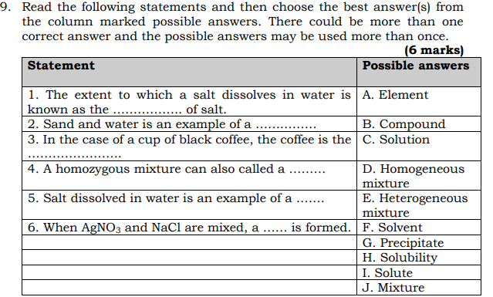

b) Name the following compunds: **/2marks**

i)NaHCO3

ii)CS2

c)Write down the chemical formulae for the following compunds: **2marks**

i)Ammonium sulphate

ii)Aluminium hydroxide

19.You are provided with substance Y. Study the observations in the table below and deduce the type of cations and anion that present in substance Y.

|  |  |  |  |
| --- | --- | --- | --- |
| Test | Y(solution)+reagent | Observation | Possible ions present ( symbols of ions) |
| 1 | Y(aq) + NaOH | Pale blue precipitate formed |  |
| 2 | Y(aq) +KI (aq) | Brown precipitate formed |  |
| 3 | Y +Na2CO3(aq) | Pale blue precipitate formed |  |
| 4 | Y +NH3(aq) then add in excess of NH3(aq) | Pale blue precipitate formed that turns deep blue in excess of NH3 |  |
| 5 | Y(aq) + BaNO3 (aq) | White precipitate formed |  |
| 6 | Y(aq) + Mg (s) | Brown solid deposited on the bottom of the test tube |  |

1. Copy the table and write the possible ions present in tests 1, 2,3,4,5, and 6 respectively, **6marks**
2. Cation present in Y is ………….**1mark**
3. Anion present in Y is …………...**1mark**
4. The chemical formula of substance Y is**2marks**

“END”