RFEPUBLIC OF RWANDA

MINEDUC

GATSIBO DISTRICT

SUBJECT: ENGLISH

CLASS: P2 ALL

NAMES ………………………………………………………………………….

INSTRUCTIONS: - WRITE YOUR NAME AND CLASS

* USE BLUE OR BLACK PEN
* THIS SECTION CONSISTS OF THREE SECTIONS

SECTION A: COMPREHENSION AND VOCABULARIES

SECTION B: GRMMAR

SECTION C: COMPOSITION

* ALL QESTIONS ARE COMPULSORY.

END OF SECOND TERM TERM EXAM FOR PRIMARY TWO (P2ALL) / 80 marks

SECTION A: 1. READ THE PASSAGE.

My name is Jane. I live in Muhanga. I walk home from school. from school gate I walk straight on the road until I get to the corner. Then I turn left. I then walk for a few minutes to the church. I cross the road at the church and then turn right. our home is opposite the huge mango tree.

1. ANSWER THE FOLLOWING QUESTIONS / 15 MARKS .
2. Which building is near jane’s home?

…………………………………………………………………………………………………………………………………………….

1. Where does jane live?

…………………………………………………………………………………………………………………………………………………

1. She walks ………………………………………………………on the roads untilshe gets to the corner.
2. She cross the road at the………………………………………………………………………………………..
3. What is the opposite jane’s home?
4. VOCABULARIES.

What is the opposite of these words. 5marks

1. right ≠…………………………………………………………………..
2. good ≠……………………………………………………………………

SECTION B. GRAMMAR.

a) ARRANGE THESE WORDS BELLOW TO MAKE CORRECT SENTENCES

me visit he. tomorrow will

…………………………………………………………………………………………………………………

1. my yesterday mother food cooked.

……………………………………………………………………………………………………………….

1. swim will next week she.

…………………………………………………………………………………………………………………

1. went I last year Kigali to.

………………………………………………………………………………………………………………..

1. are studying English we.

…………………………………………………………………………………………………………………

b) WRITE THE PAST TENS OF THE FOLLOWING

1. CLEAN :………………………………………………………………..

2. RUN:……………………………………………………………………

3. :FETCH:…………………………………………………………………

4. KEEP:…………………………………………………………………….

5. DANCE:………………………………………………………………..

2. DRAW THE FOLLOWING PARTS OF THE BODY /5MARKS

1. FOOT
2. COMB
3. NAME THE PARTS OF THE BODY SHOWN BELLOW.

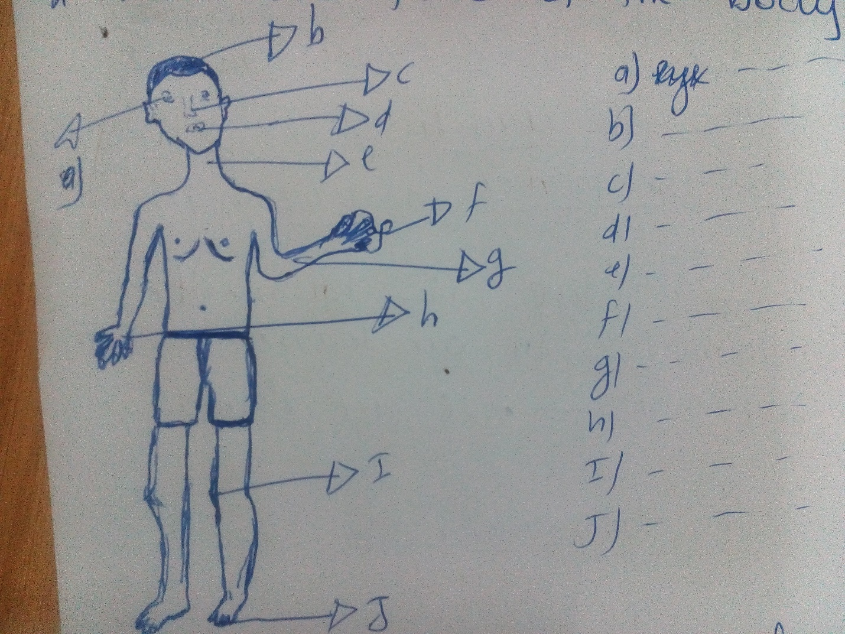

1. MATCH THESE ANIMALS WITH THE PRODUCT WE GET FROM THEM.
2. COW A) EGGS
3. RABBIT B) BEEF / MILK
4. SHEEP C) TRANSPORT
5. CHICKEN D) SKIN/MEAT
6. DONKEY E) MEAT

FILL IN THE GAPS BY USING : A FEW; OR A LOT OF. /5MARKS

1. WE have ………………………………………………..hens
2. they have………………………………………………..sheep
3. he has……………………………………………………………cats
4. Keza has……………………………………………………………goats.
5. We have ………………………………………………………….hens. They hatch many eggs.

COMPOSTION.

READ THE WORDS IN THE BOX. USE THESE WORDS TO COMPLETE THE COMPOSITION ABOUT WHERE MUTESI LIVES / 10 MARKS

|  |
| --- |
| 1 BUILDING 2. MONEY 3 THE CHURCH 4. FOOD 5. THE BREMERA 6. OPPOSITE 7. MUTESI 8. THE MARKET 9. HOSPITAL 10. BANK |

My name is …………………………………… I live in ………………………………………….. there are four community…………………………………….ion our town. these are ……………………………..;……………………………….;……………………………………………..and the …………………………………………….we get from ………………………………………

we buy ………………………………from the market the church is………………………..the road.

GOOD LUCK!!!!!!!!!!!!!!!!!!!!!!!!!!!!!!!!!!!!!!!!!!!!!!!!!!!!!!!!!!!!!!!!!!!!!!!!