RFEPUBLIC OF RWANDA

MINEDUC

GATSIBO DISTRICT

**SUBJECT: ENGLISH**

**CLASS: P2 ALL**

NAMES ………………………………………………………………………….

INSTRUCTIONS: - WRITE YOUR NAME AND CLASS

* USE BLUE OR BLACK PEN
* THIS SECTION CONSISTS OF THREE SECTIONS

SECTION A: COMPREHENSION AND VOCABULARIES

SECTION B: GRMMAR

SECTION C: COMPOSITION

* ALL QESTIONS ARE COMPULSORY.

END OF SECOND TERM TERM EXAM FOR PRIMARY TWO (P2ALL) / 80 marks

SECTION A: 1. READ THE PASSAGE AND ANSWER THE QUESTION.

Mugiraneza lives with his mother and father in bwakira.his parents wake up at 5:45 a.m. every day. his mother cleans the house. after that she makes breaks-fast for the family. his father milks the cows. later, the family takes break-fast. Then Mugiraneza goes to school at 7:00 a.m.

1. ANSWER THE QUESTIONS / 15MARKS.
2. Mugiraneza ‘s mother and father woke up at…………………………………………………………………….
3. Who cleans the house?...............................................................................................
4. Mugiraneza’s father ………………………………………….the cow.
5. How many people are in Mugiraneza’s family?
6. Mugiraneza goes to school at ……………………………………………………………………………..
7. VOCABULARIES.

2. FILL IN THESE BLANK SPACES WITH: WHERE WHAT OR WHEN.

A. ……………………….Does your sister woke up?

B. ………………………Does your uncle live?

C. ……………………..Is her job?

D. ………………………Do you come from?

E. ………………………IS your mother job?

SECTIION B. GRAMMAR.

1. MATCH THE PERSON WITH THEIR JOB. /10MARKS.
2. NURSE 1. Aperson who grow crops or keeps animals.
3. TEACHER 2. Aperson who take care to the patient.
4. A FARMER 3. A person whose job is making and reparing

wooden object structure.

1. BUTCHER 4. Apersonn who teach pupils in a school.
2. CARPENTER 5. Aerson who sels meat.
3. USE FULL STOP AND CAPITAL LETTERS /6MARKS
4. mary is going to Kigali.
5. agnes and jesca lives in huye

CHOOSE THE CORECT ANSWER INTO THE BLACKETS. / 10marks

1. I…………………………….a boy. ( am, is, are,).
2. She ………………………mago ( like, likes, ).
3. We …………………………the students ( am, are, is ).
4. Thy ……………………………….. pencil ( have , has.).
5. You …………………………………….in Huye ( lives , live,)

COMPLETE THE SENTENCES BY USING WORD GIVEN INTO THE BOX. /9marks

|  |
| --- |
| DINNER, LUNCH, BREAKFAST |

1. I eat …………………………….. at six o’clock in the morning.
2. At half past twelve in the afternoon, I eat ………………………………………………..
3. At six o’clock in the evening, I eat ………………………………………………….

5. COPY THE TABLE BELOW WITE TWO EXAMPLES OF FOOD IN EACH COLUMN / 8MARKS

|  |  |  |  |
| --- | --- | --- | --- |
| FRUITS | VEGETABLES | CEREALS | MEAT |
| 1-  2- | 1-  2- | 1-  2- | 1-  2- |

6. WHAT TIME IS IT? /2MARKS

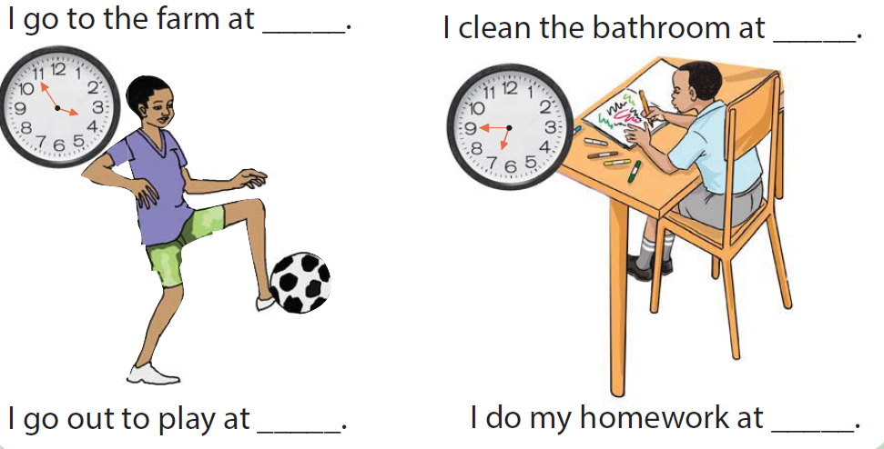…………………………………………………………………………………………………..

SECTION C : COMPOSTION. /3MARKS

1. A. FILL THESE SENTENCES.
2. There are ………………………………….days of the week.
3. Which months are in one year? ……………………………………………………………..
4. One year has ………………………………………………………………..months.
5. TALK ABOUT YOURSELF /12MARKS

My name is …………………………………………………………………………………………………

I am ………………………………………………………………………………………………..years old.

I live in ………………………………………………………………………………………..village.

I like to play ……………………………………………………………….game.

I am in primary…………………………………………………………………………………………

Our English teacher is called………………………………………………………………………….

GOOD LUCK !!!!!!!!!!!!!!!!!!!!!!!!!!!!!!!!!!!!!!!!!!!!!!!!