RFEPUBLIC OF RWANDA

MINEDUC

GATSIBO DISTRICT

SUBJECT: ENGLISH

CLASS: P1 ALL

NAMES ………………………………………………………………………….

INSTRUCTIONS: - WRITE YOUR NAME AND CLASS

* USE BLUE OR BLACK PEN
* THIS SECTION CONSISTS OF THREE SECTIONS

SECTION A: COMPREHENSION AND VOCABULARIES

SECTION B: GRMMAR

SECTION C: COMPOSITION

* ALL QESTIONS ARE COMPULSORY.

END OF SECOND TERM TERM EXAM FOR PRIMARY ONE (P1ALL) / 80 marks

SECTION A: READ THE STORY.

MY Name is Anna. I am a girl.

I am Eight years old.

This is my cat. Her name is kitty

She is a nice cat. I like her.

1. Use word from the story. Complete these sentences/ 15 marks
2. My name is……………………………………………………………………….
3. I am …………………………………Years.
4. This is ……………………………………………. Cat.
5. She is a nice ………………………………………………...
6. I like …………………………………………………………………………………...
7. VOCABULARIES /5marks

fill the missing letters

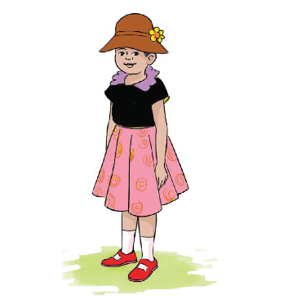 G…RL  
8 E..GHT

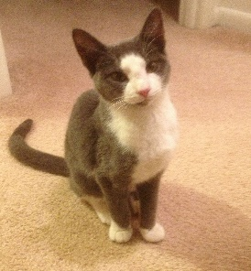 C…T

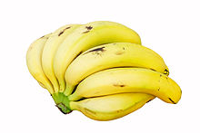 BAN…N…

* B…G

SECTION B

MATCH THE PICTURES WITH THEIR NAME / 10MARKS

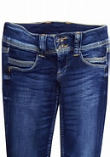 A) TABLE

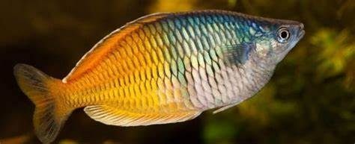 B) BAG

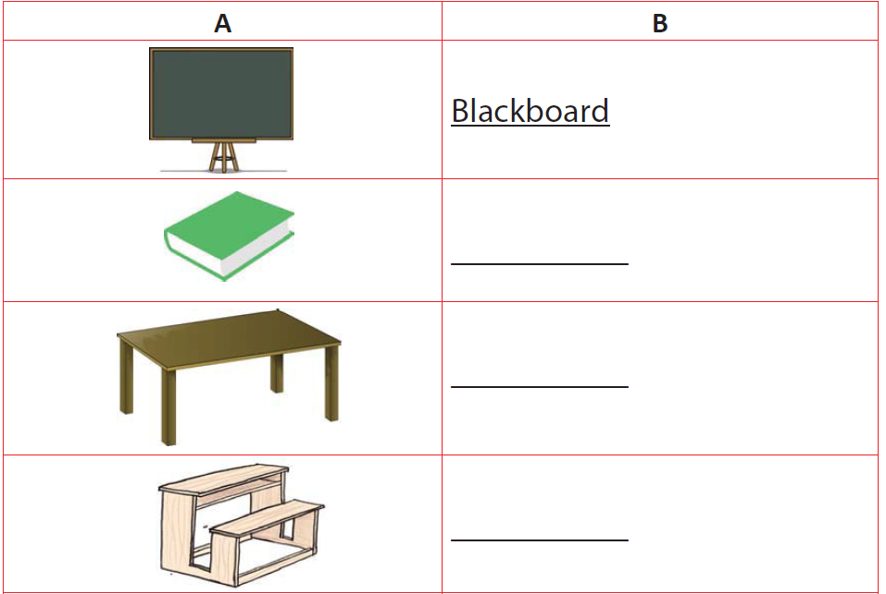 C) CHAIR

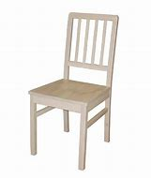 D) FISH

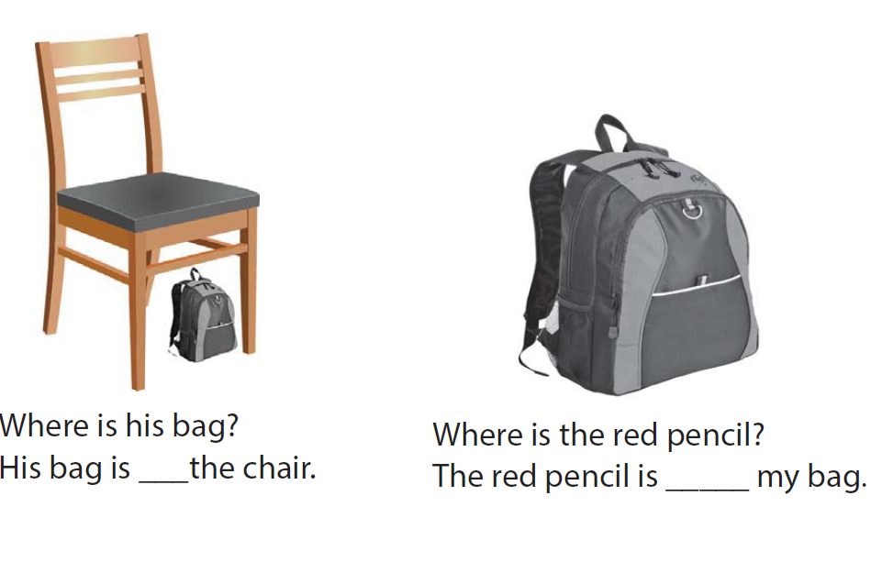 E) TROUSER

2. COMPLET WITH THIS AND THAT /4MARKS

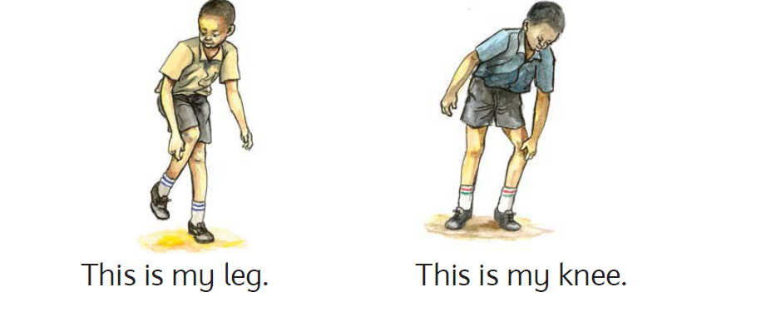 ……………..LEG

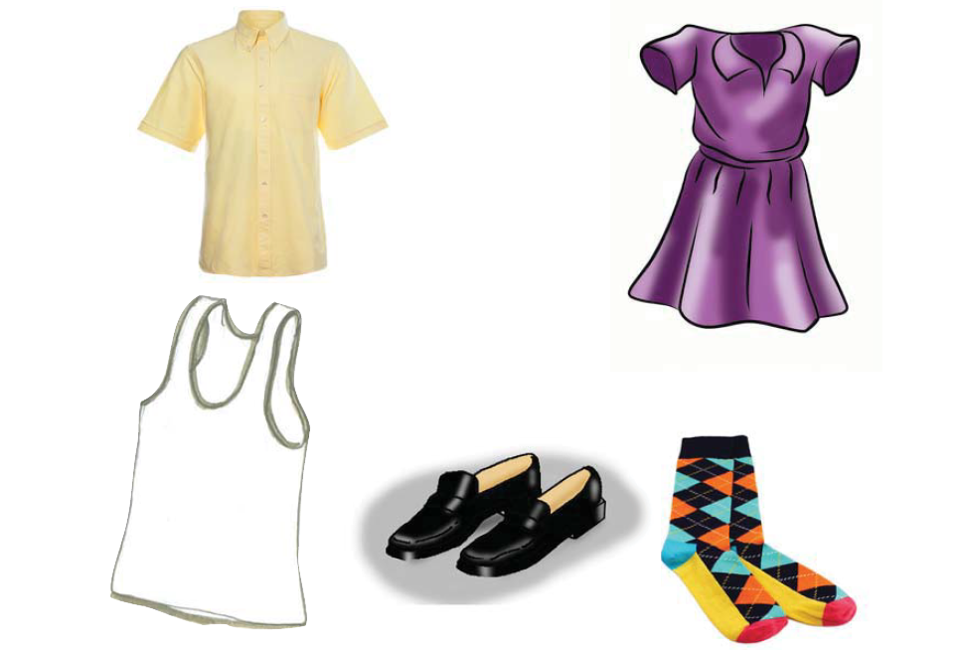 ……………………………….DRESS

3. USE HAS OR HAVE /4marks

a. He ………………..a mango

b. YOU ……………a book

PUT THESE WORDS INTO PLURAR /10 marks

1. 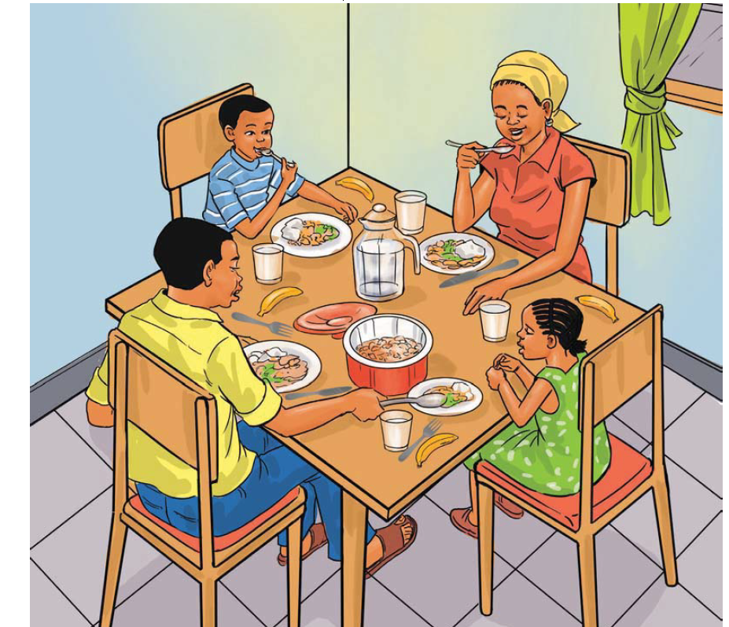 banana 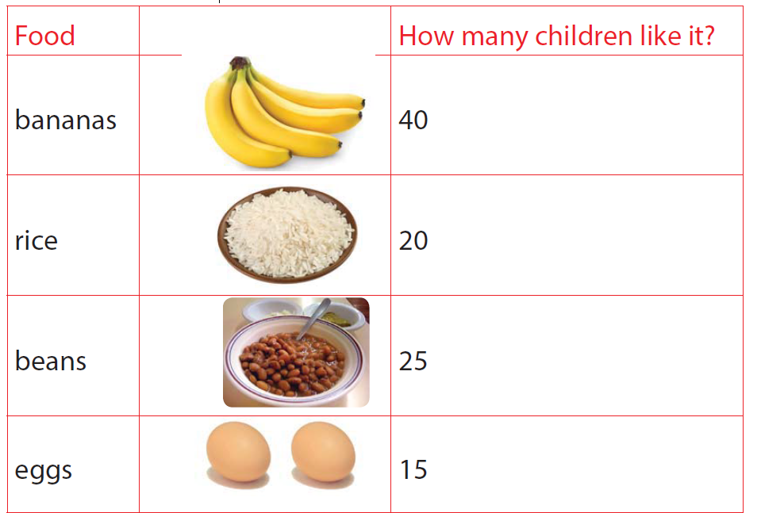 ……………………………………
2. 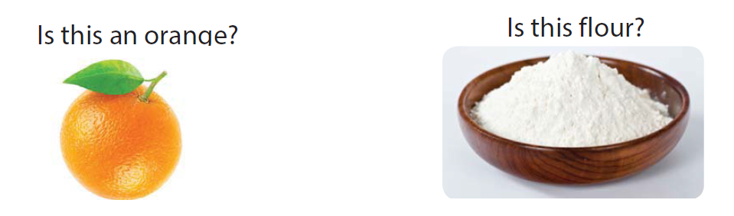orange 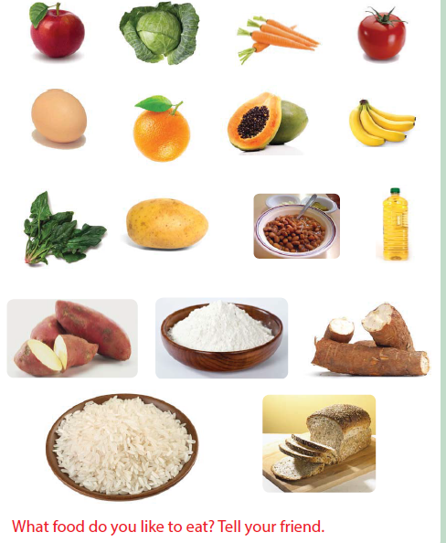………………………….

c.  egg ……………………………………….

d.

 mango ………………

e. 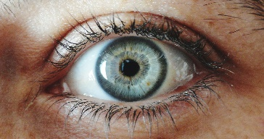 eye 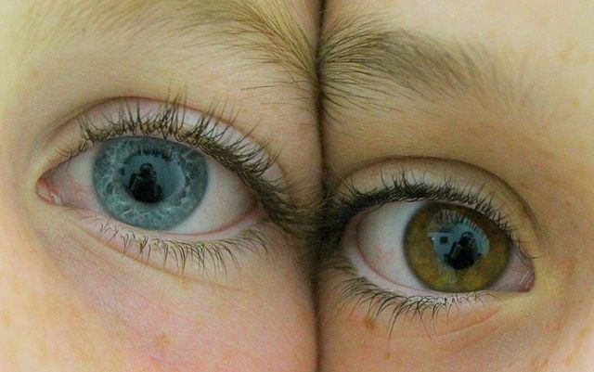 ………………………………………….

f) a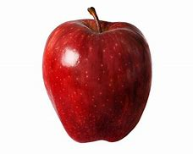 apple 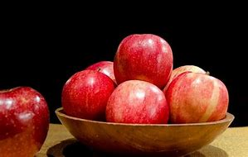 …………………………………..

4. USE MY ; YOUR; HIS; HER ; OUR TO COMPLETE THE SENTENCES.

1. I have a pen. This is……………………………pen.
2. He has a pencil. That is ……………………..pencil.
3. She has a dress. That is ……………………………. dress.
4. You have a bag. This is ………………………………bag.
5. We have a chair. That is ……………………………..chair.

FILL IN THE BLANK WIT : UNDER; ON; NEAR /12marks

1. 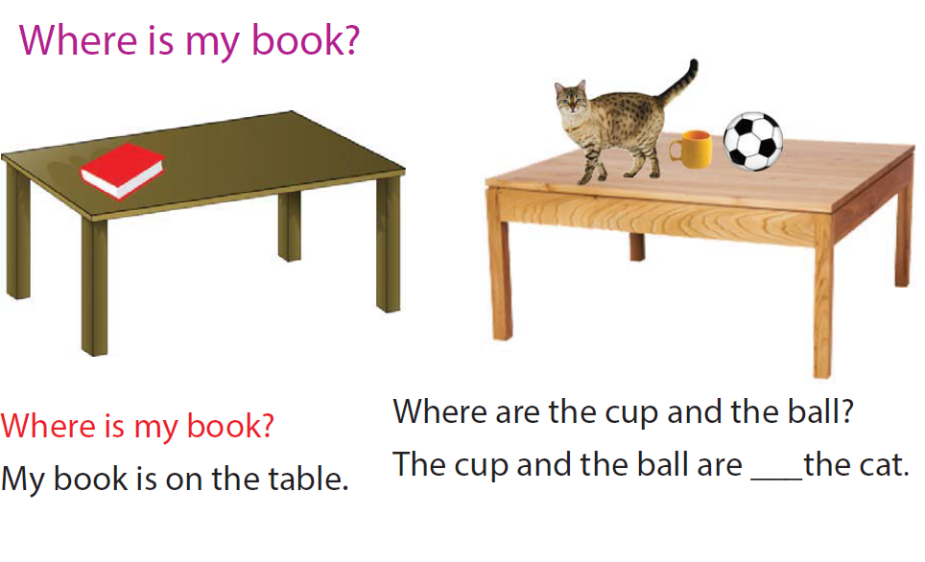MY BOOK IS …………………THE TABLE
2. HIS BAG IS ………………………………………….THE CHAIR.
3.  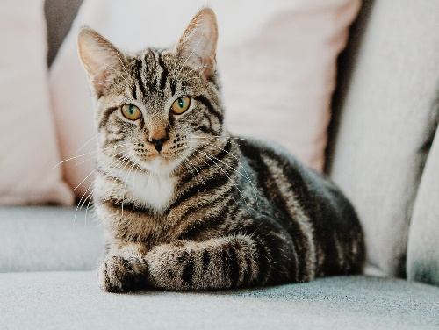

THE CAT IS ………………………………….THE CHAIR.

COMPOSITION

TALK ABOUT YOUR SELF

my name is ………………………………………………….i am ………………….yearsn old.

I am a ……………………….(boy/girl)

I like …………………………………………………..

I am in primary………………………………………………………………………………

GOOD LUCK!!!!!!!!!!!!!!!!!!!!!!!!!!!!!!!!!!!!!1