**MINEDUC**



**EASTERN PROVINCE**

**GATSIBO DISTRICT**

**ORDINARY LEVEL CANDIDATES’ PHYSICS EXAMINATIONS**

**SECOND TERM, 2023**

**SUBJECT: PHYSICS I**

**LEVEL: S3**

**DATE… /03/2023**

**DURATION: 3 HOURS**

**INSTRUCTIONS:**

This will be one paper of **20** Questions that a candidate will sit for, in three hours.

This comprehensive assessment paper will be made of **three** sections **A, B** and **C** Carrying **100** Marks in total.

**SECTION A**: A candidate will answer all **14** questions in total of **55** Marks

**SECTION B**: This Section will be comprised of **5** questions; each question set on 10 marks. A candidate will attempt **three questions (3)** of his / her choice on **30** marks.

**SECTION C**: This Section will be comprised of **1question** which is compulsory Carrying **15** Marks.

**SECTION A: ATTEMPT ALL QUESTIONS**

1) a) Define centre of gravity of an object. **(1Mark)**

b) Enumerate any two conditions for a body to be in stable equilibrium.

**(2Marks)**

2) Complete the following statements

a)…………………. Is a form of energy. **(1Mark)**

b) Stored energy that depends upon the relative position or state of an object is called……………….**(1Mark)**

c) When a body is lifted from the ground to a certain height, the work is done on the body against the…………….**(1Mark)**

d) The amount of energy transferred or converted per unit time is called………………..**(1Mark)**

3) Answer **True** or **false** to the following;

a) Pinhole camera produces an erect image. **(1Mark)**

b) A shadow is formed because light travels in straight line. **(1Mark)**

c) The moon is a luminous object. **(1Mark)**

d) The number of images formed in two plane mirrors inclined at an angle Ɵ to each other is given by the formula n=(360/ Ɵ) +1. **(1Mark)**

4. Match the electronic component in column **A** with is use in column **B**.

**(4Marks)**

|  |  |
| --- | --- |
| **Column A** | **Column B** |
| 1.Ordinary diodes | a. Amplification of alternating current. |
| 2. Transistors | b. Electronic wireless devices which is mainly used everywhere in communication. |
| 3. Mobile phones | c. Resist changes in electric current and store electric energy in magnetic field. |
| 4. Inductor | d. Rectification of alternating current power to direct current power. |

5) Choose the correct answer in the statements a, b and c. **(1Mark)**

a) The constant physical quantity of Boyle’s law is

i) Only mass of the gas

ii) Only temperature of the gas

iii) Mass and pressure of the gas

iv) Mass and temperature of the gas.

b) The nature of the volume – temperature graph in Charles law is **(1Mark)**

i) Straight line

ii) Parabola

iii) Hyperbola

iv) Ellipse

c) In an ideal gas equation , PV=nRT **(1Mark)**

i) n is the number of molecules of the ideal gas

ii) V denotes volume of one mole of the ideal gas

iii) n moles of the ideal gas have a volume

iv) P is the pressure of the ideal gas when only one mole of a gas is present.

6) a) Name any two methods of making magnets. **(2Marks)**

b) State any two fundamental particles of an atom. **(2Marks)**

7) a) What happens when a positively charged object is brought near a neutral object ? Explain your answer. **(2Marks)**

b) When a glass rod is rubbed with silk, the glass rod get positive electric charge. Explain why. **(1Mark)**

c) Describe what will happen to the electric potential created by electric charge at a point, if the distance between the electric charge and the point is doubled.

**(1Mark)**

8. a) Why are water tanks placed at the highest places? **(1Mark)**

b) Does an object create more or less pressure when its surface area is smaller? Explain your answer. **(2Marks)**

9) Differentiate between linear momentum and impulse **(3Marks)**

10) a) How does force differ from pressure? **(2Marks)**

b) Why is the atmospheric pressure higher at sea level? **(1Mark)**

c) How does the atmospheric pressure help you drink through a drinking straw? **(1Mark)**

11) a) In a hydraulic system, a piston with a cross- sectional area of 21cm2 pushes on an incompressible liquid with a force of 38N. The far end of the hydraulic pipe connects to second piston with a cross- sectional area surface of 100cm2. What is the force of the second piston? **(4Marks)**

b) A piston that is part of hydraulic system has a surface area of 0.025cm2. The hydraulic fluid pushes on the piston with a pressure of 20000Pa. What pressure pushes on another piston in the same system? Justify your answer.

**(4Marks)**

12) In a certain process 820J of heat is added to a system. The system does work equivalent to 725J by expanding against the surrounding atmosphere.

a) Is the work done by the system on the surrounding positive or negative?

**(1Mark)**

b) Calculate the changes in internal energy for the system. **(2Marks)**

13) Compare renewable and non-renewable energy sources. **(4Marks)**

14) A student with a mass of 40kg is running with a velocity of 2m/s.

a) Calculate the kinetic energy of the student.**(2marks)**

b) What would be the kinetic energy of the student if the velocity was

doubled? **(2marks)**



15.

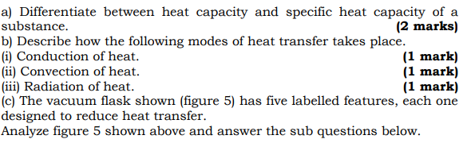

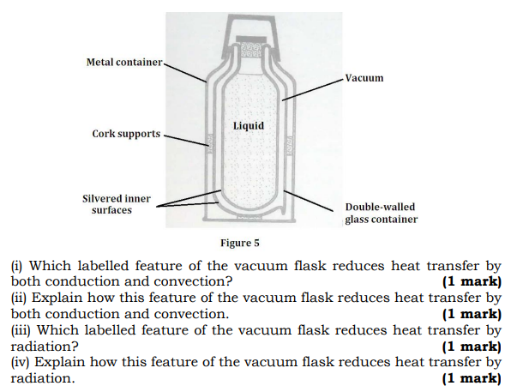

16.

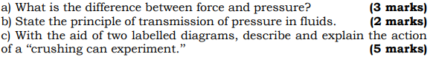

17

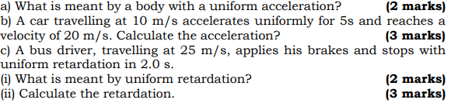

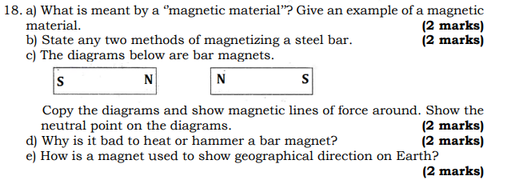

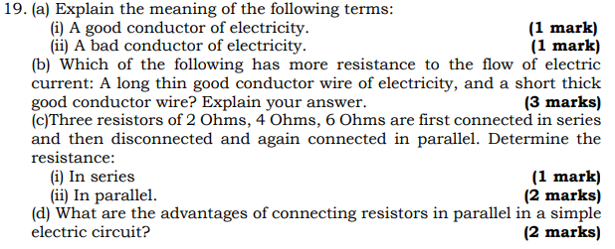



20.

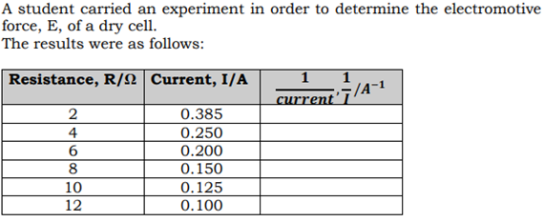

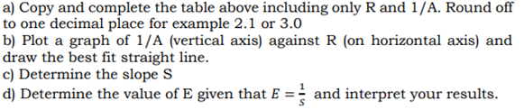

…………………….END………………………..