**MINEDUC**



**EASTERN PROVINCE**

**GATSIBO DISTRICT**

**ORDINARY LEVEL CANDIDATES’ PHYSICS EXAMINATIONS**

**SECOND TERM, 2023**

**SUBJECT: PHYSICS I**

**LEVEL: S2**

**DATE… /03/2023**

**DURATION: 3 HOURS**

**INSTRUCTIONS:**

This will be one paper of **16** Questions that a candidate will sit for, in three hours.

This comprehensive assessment paper will be made of **three** sections **A, B** and **C** Carrying **100** Marks in total.

**SECTION A**: A candidate will answer all **10** questions in total of **55** Marks

**SECTION B**: This Section will be comprised of **5** questions; each question set on 10 marks. A candidate will attempt **three questions (3)** of his / her choice on **30** marks.

**SECTION C**: This Section will be comprised of **1question** which is compulsory Carrying **15** Marks.

**SECTION A: ATTEMPT ALL QUESTIONS**

1. Fill in the blanks the missing words using: **“Pa, F/A , force, N/m2, ML-1T -2, LT -1, increased, 6 Pa”** Pressure tells us how concentrated a ------------ is. It is measured in ---------- or --------- and is calculated using the equation: p = ------------. A force of 12N acting over an area of 2m2 causes a pressure of ------------. If the area were less, the pressure would be ----------------------. The dimensions of velocity are ----- -------. The dimensions of pressure are ------------- **8 Marks**

2. Fill in the blanks using: **“Nature, the motion, less, unnecessary heat, reduces”.**

(a) Friction opposes the ________ between the surfaces in contact with each other.

(b) Friction depends on the _________ of surfaces.

(c) Friction produces _________.

(d) Sprinkling of powder on the canon board ________ friction.

(e) Sliding friction is ________ than the static friction. **5 Marks**

3. Which of the shoes shown below causes most damage? Explain your answer

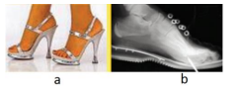

Explain your answer

4. Among the following quantities: Mass, Force, Acceleration, length, Pressure and Temperature. which ones are:

a) Fundamental **4Marks**

b) Derived physical quantities? **2Marks**

5. Choose the best answer

a) The number of significant digits in 0.0006032 is

i) 8 ii) 7 iii) 4 iv) 2 **2 Marks**

b) If the average velocity of an object is zero in some time interval, what can you say about the displacement of the object for that interval?

i) Increased ii) Decreased iii) Zero iv) None of the above

**2 Marks**

c) Mercury has a density that is about 14 times greater than that of water. If you were to build a barometer that uses water instead of mercury, how would the height of the column of water needed compare to that of the mercury**. 2 Marks**

i) higher than ii) lower than iii) equal to iv) can’t tell

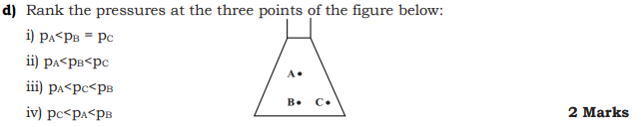

e) If an object flies into space, its

i) mass and weight both would remain same

ii) mass would change but weight would remain same

iii) mass would remain same but weight would change

iv) mass and weight both would change **2 Marks**

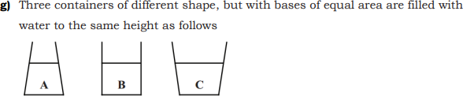

I. The weight of the water is the greatest in container…

(i) A (ii) B (iii) C (iv) The weight of the water is the same in all the three containers. **2 Marks**

II. The pressure at the bottom of the container is the greatest in container…

(i) A (ii) B (iii) C (iv) The pressure at the bottom is the same in all the three containers **2 Marks**

6. How long will it take a car to accelerate from 10m/s to 35m/s at a constant acceleration of 5m/s2 in a straight line? **4 Marks**

7. Ineza has to push a lighter box and Shema has to push a similar heavier box on the same floor. Who will have to apply a larger force and why? **4 Marks**

8. Given that the atmospheric pressure at Genting Highland is 72cmHg. Find the equivalent value of this pressure in the unit of Pascal (Pa). [density of mercury = 13600 kgm-3] **3 Marks**

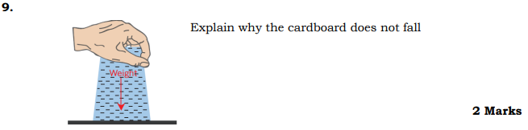

10. a) A force of 20N pushing an object 5m in the direction of the force. How much work is done? **2Marks**

b) If you do 100 joules of work in one second (using 100 joules of energy). How much power is used? **2Marks**

**SECTION B (Answer 3 questions of your choice)**

11. State and explain 3 applications of atmospheric pressure

**10 Marks**

12. A 5kg object is sliding to the right and encountering a friction force which slows it down. The coefficient of friction (μ) between the object and the surface is 0.1 Determine the weight, the normal force, the force of friction. (Neglect air resistance) Consider g=10N/Kg

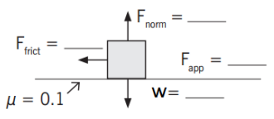

13.

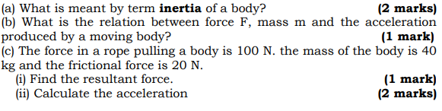

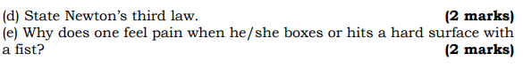

14. The following figure shows a hydraulic weight bridge which works on the principle of Pascal’s law.

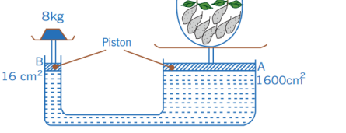

a) What is the pressure at B? **4Marks**

b) What is the pressure at A? **2Marks**

c) What is the weight of the vegetable on the large piston A if the weight bridge is in equilibrium? **4Marks**

15.

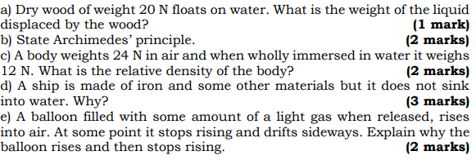



**16.**



**……………………………………END…………………………………………**