**GATSIBO DISTRICT**

**SUBJECT: BIOLOGY AND HEALTH SCIENCE**

**DATE: 23/02/2023**

**CLASS: SENIOR TWO**

**DURATION: 3Hrs**

## **Instructions: -Attempt all questions in A and three in B**

**-Section C is Compulsory**

**SECTION A** (**Attempt all questions in this section)**

**1.** What features are (a) Possessed by both plants and animals? **(2marks)**

(b) Possessed by plants only? **(2 marks)**

**2.** a) Draw a line to link the name of the life process with its meaning. One is done for you. **(3 marks)**

. 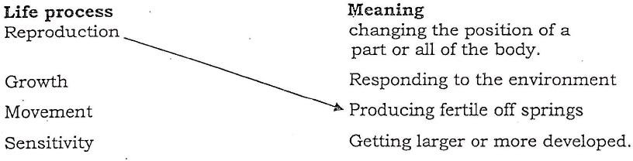

b) The following are parts of an organism: Cell, organ, chromosome, system, gene, tissue. Arrange them in decreasing order of size.

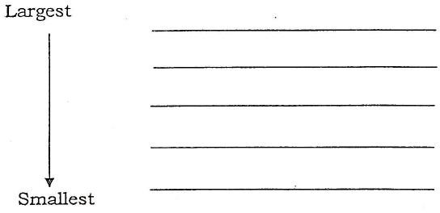 **(3 marks)**

**3.** a) Complete the classification of a man below: **(2 marks)**

Kingdom: Animalia

Phylum: Chordata

Class: Mammalia

Order: Primates

Family: …………

Genus: ………

Species: *Homo sapiens*

b) Define the term species. **(1mark)**

**4.**Which characteristics distinguish insects from other animals? **(3 marks)**

**5.** Proteins help in body building. Starch provides energy.

(a)Give one reason for a child's diet being rich in proteins. **(1 mark)**

(b)Give one reason for the diet of an elderly person requiring proteins.

**(1 mark)**

(c) Would a sugar cane cutter diet require more starch than that of a School teacher? Give a reason for your answer. **(2marks)**

**6.** Plants need mineral salts.

(a)Through which part do mineral salts get into the plant? **(1 mark)**

(b)Explain why water is important in this process. **(2 marks)**

1. (a) Define osmosis. **(2 marks)**

(b) Explain why osmosis is considered a special case of diffusion. (2**marks)**

1. Match the following organisms using an arrow with the structures for gaseous exchange. **(6marks)**

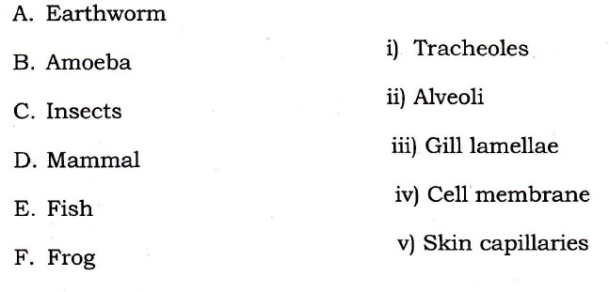

1. What is the function of each of the following cell organelle?
   1. Mitochondrion. **(1 mark)**
   2. Chloroplasts. **(1 mark)**
   3. Golgi apparatus. **(1 mark)**
   4. Endoplasmic reticulum. **(1 mark)**

**9.** (a) State two features of a good gaseous exchange system. **(2 marks)**

(b)Describe the route taken by the air as it is inhaled. **(3 marks)**

(c)Name the air sacs in the lungs. (**1 mark)**

**10.** a) Define photosynthesis. **(2 marks)**

(b) What conditions are necessary for photosynthesis to occur in a green plant? **(4 marks)**

11. (a) What features (adaptations) of fish enable it to live in water? **(3 marks)**

(b) Why does fish die immediately it is removed from water? **(3 marks)**

**SECTION B. (Attempt only three questions in this section)**

12. Plants absorb water and dissolved mineral salts from the soil.

(a)What do plants make from the following minerals?

* + - 1. Magnesium **(1 mark)**
      2. Nitrates **(1 mark)**
    1. Give two reasons why water is important for plants. **(2 marks)**
    2. Which plant vessels transport water and sugar? **(2 marks)**
    3. Explain how water rises up the plant. **(4 marks)**

13.(a) What is an enzyme? **(2 marks)**

1. Describe the characteristics of enzymes? **(6 marks)**
2. What part is played by enzymes in the germination of maize? **(2 marks)**

14. Cholera is a highly dangerous disease which is spread by bacteria. It is spread by eating or drinking food or water which is contaminated with the bacteria.

a) Which part of the body is likely to be infected first when someone drinks water containing the cholera bacteria? **(1 mark)**

b) Explain how the cholera bacteria inside the body may cause disease.

**(2 marks)**

c) Name other groups of microbes that frequently cause disease. **(1 mark)**

People crowded together in refugee camps are likely to catch the disease. Explain why. **(3 marks)**

(e)Explain how the body defends itself against bacteria. **(3 marks)**

15.a) Describe the different types of carbohydrates giving examples of each type. **(5marks)**

b) You are provided with a solution which is suspected to contain reducing sugar. Describe the possible tests you can carry out to confirm that it is a reducing sugar. **(5 marks)**

16.a) Explain the following terms that are used in ecology.

1. Biosphere **(1 mark)**
2. Habitat **(1 mark)**
3. Niche **(1 mark)**
4. Producer **(1 mark)**

b) Answer the following questions in relation to the food web shown below.

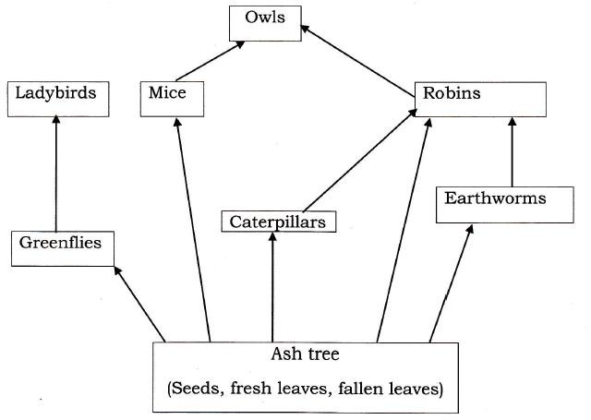

(i)Write two food chains with four organisms in it. **(2 marks)**

(ii)Copy and complete the table below. **(4 marks)**

|  |  |
| --- | --- |
| Autotrophic organism |  |
| Secondary consumer |  |
| Omnivore |  |
| Carnivore |  |

**SECTION C: This question is compulsory. (15 marks)**

**17.**) a) The students performed the experiment illustration below.

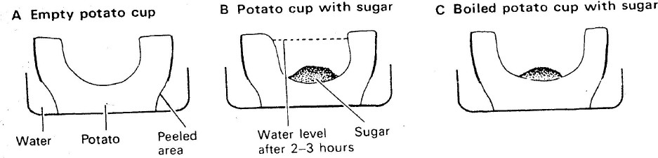

(i)Explain in details why water gathers in the hollowed portion of potato B. **(5 marks)**

(ii)Explain why water does not gather in the hollowed potion of potato A and C. **(5 marks)**

(iii)Why is potato A necessary in the experiment? **(5 marks)**

**GOOD LUCK**