**GATSIBO DISTRICT**

**END OF SECOND TERM EXAMINATION**

**SUBJECT: BIOLOGY AND HEALTH SCIENCE**

**DATE: 23/02/2023**

**CLASS: SENIOR THREE**

**DURATION: 3Hrs**

**Instructions: -Attempt all questions in A and three in B**

**-Section C is Compulsory**

**SECTION A** (**Attempt all questions in this section)**

1.(a) (a) Name two structures possessed by plant cells that are absent in the animal cell. **(2 marks)**

(b) Name the processes by which plant cells obtain their:

1. Mineral salts
2. Carbon dioxide
3. Water **(3 marks)**

2. (a) State the name of the type of muscle found in the heart. **(1 mark)**

(b) Name the blood vessel that:

1. Carry blood away from ventricles. **(2 marks)**
2. Carry blood back the ventricles. **(2 marks)**

3.Describe how oxygen is transported around the body cells.

**(3 marks)**

1. Where are the following digestive substances produced? **(4 marks)**
2. Bile
3. Amylase
4. Lipase
5. Protease

5.A group of students studied the feeding relationship in a pond. The Food Web below shows their results.

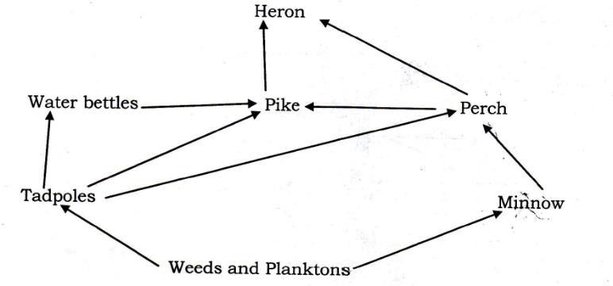

* 1. What information is given by the arrows in this Food web? **(2 marks)**
  2. A disease killed most of the Minnows. Explain the likely effect of the death of most minnows on the following organisms in the pond:
     1. Perch **(2 marks)**
     2. Tadpoles **(2 marks)**
     3. Planktons **(2 marks)**

6. Photosynthesis takes place in cells containing chlorophyll.

* 1. What colour is chlorophyll? **(1 mark)**
  2. Where in a cell is chlorophyll found? **(1 mark)**
  3. what is the function of chlorophyll? **(1 mark)**

7. (a) Define osmosis. **(2 marks)**

(b) Explain why osmosis is considered a special case of diffusion. (2**marks)**

8. Explain why the elimination of water by the kidney may be considered to be both excretion and osmoregulation. **(4 marks)**

9. Describe how water balance is maintained in the human body. **(4marks)**

10. (a) What features (adaptations) of fish enable it to live in water? **(2marks)**

(b) Why does fish die immediately it is removed from water? **(2marks)**

11.If sucrose is tested using Benedict’s test for reducing sugars, no change is observed. The bonds between the glucose and fructose must be broken before the test for reducing sugars.

Describe how the bond can be broken chemically. **(3 marks)**

12.a. Explain limiting factors of photosynthesis. **(4marks)**

b. Explain the importance of photosynthesis**. (4marks)**

**SECTION B. (Attempt only three questions in this section)**

13. (a) Define the term Photosynthesis. **(2 marks)**

(b)What are necessary conditions for photosynthesis to take place? **(4marks)**

(c)What factors may affect the rate of photosynthesis? **(4 marks)**

14. (a) What is an antigen? **(1 mark)**

(b) There are four (4) blood groups: **A**, **AB**, **B** and **O**. From these blood groups, show the possible blood compatibility for transfusion. **(9 marks)**

15. Briefly explain how:

a) The flow of blood is maintained in a mammal. **(5 marks)**

b) The flow of water is maintained in a flowering plant. **(5 marks)**

16.a) a) (i) What is hormone? **(1 mark)**

(ii) Where are hormones produced? **(1 mark)**

b) Which hormones are produced by the pancreas? **(2 marks)**

c)Explain how the blood sugar level in blood is controlled. **(6marks)**

**17.** (a) What are functions of the stomach in the digestion of man?

Define the term "Digestion". **(1 mark)**

(b)Name any three protein digesting enzymes. **(3 marks)**

(c) Mention any six healthy nutritional habits we are advised to practice. **(6 marks)**

**SECTION C: This question is compulsory. (15 marks)**

**18.** Describe an experiment you would carry out to test solutions suspected to contain.

1. Glucose
2. Sucrose

In your description, show the procedures, observations and conclusion. **(15 marks)**

**GOOD LUCK**